Take Time for a Stretch Break!
Stretching can help muscles and joints be flexible, strong, and able to perform a proper range of motion which can help prevent injuries, protect our mobility, and maintain independence. Without flexibility, muscles become shorter and tighter, leading to the potential for pain and injury. For example, sitting for prolonged periods can cause stiff leg muscles which makes movements like walking or standing up difficult or painful. We can help our body by taking small breaks to stretch. Here are some helpful tips to consider when beginning a new stretching routine.

- Warm up first! Stretching cold muscles can increase the risk of injury. A light 5–10-minute walk can help warm up your muscles.
- Equality is key! Focus on both sides of each muscle group. Having one side of your body more flexible than the other may lead to balance issues and/or injury.
- Pain is not the goal! Too much strain will cause your muscles to feel pain and discomfort. The goal should be to feel comfortable tension. Hold the stretch for 30 to 60 seconds when you reach this point.
- Remember to breathe! Control your breathing when you are adding tension to your muscles. Inhale when adding tension and exhale when releasing tension.
- Focus on major muscle groups. Focus on hips, lower back, shoulders, neck, calves, and thighs as part of your stretching routine along with other muscles and joints you use daily.
- Slowly incorporate movement. Yoga, Tai Chi, and Pilates uses slow movements that help increase flexibility and prevent falls in older adults.

A regular stretching routine includes stretching for at least 5-10 minutes at a time at least 3 times a week. If you skip or miss stretching throughout the week, that is okay! You may lose some flexibility, but you can always start again and gain it back! If you have a chronic condition or injury, speak with your doctor or physical therapist before you begin a new stretching routine.

Written by: Natalie Ramos, Bexar County Extension Agent – Better Living for Texans
Content Source: Harvard Health, The Importance of Stretching, 2022
Photo From: Better Living for Texans

Local Events

Recipe of the Month

Recipe from Barbara Brown, West Region Project Specialist – Better Living for Texans

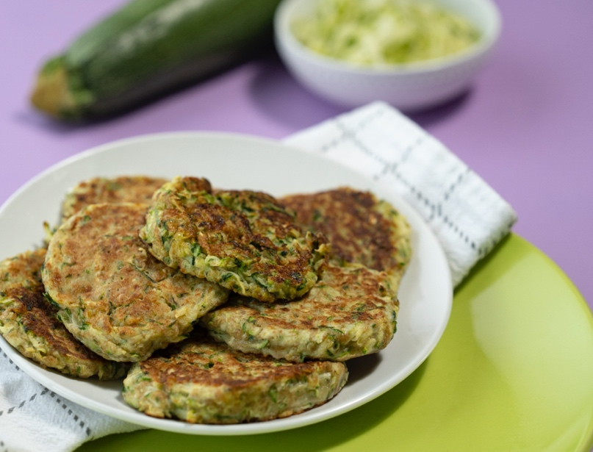
Zucchini Fritters

Vegetable fritters can be a great anytime snack. You can make them in batches, freeze the extras, and warm them before eating.

Ingredients
2 | small to medium zucchinis
1/3 | cup whole wheat flour
1 | egg, lightly beaten
2 | thinly sliced green onions
1/4 | teaspoon salt
1/8 | teaspoon pepper
1 | tablespoon oil

Directions
- Wash zucchini and cut off ends. Grate the zucchini using a box grater. Let the zucchini sit for about 10 minutes to start releasing liquid. Place the zucchini on a clean kitchen towel. Wrap the zucchini in the towel and squeeze out as much liquid as possible. Do not skip this step.
- Transfer the zucchini to a large bowl. Add the flour, green onions, salt, and black pepper to the bowl and stir. Stir in the egg until the mixture is combined.
- Heat oil in a skillet on medium heat. Scoop ¼ cup of the zucchini mixture into the skillet, pressing lightly into a round with a spatula. Cook fritters on each side for 2 to 3 minutes until golden brown and thoroughly cooked. Transfer zucchini fritters to the paper towel-lined plate. Repeat with remaining zucchini mixture.

Nutrients Per Serving: 90 calories, 5 g total fat, 1 g saturated fat, 40 mg cholesterol,
170 mg sodium, 10 g carbohydrates, 2 g fiber, 2 g total sugar, 0 g added sugar, and 4 g protein.

Total Cost: $$$$

