Enjoy vegetables in a variety of ways!
Many can clearly picture the scene as someone (maybe even you!) wrinkles their nose to a certain food group in front of them. Any guesses on what food group it could be? A safe guess would indeed be the vegetable group. Some may assume that if they try and dislike a vegetable once, they will never enjoy that vegetable prepared another way. While everyone has different food preferences, it might be time to try the vegetable prepared differently. Fortunately, there are many ways to enjoy!

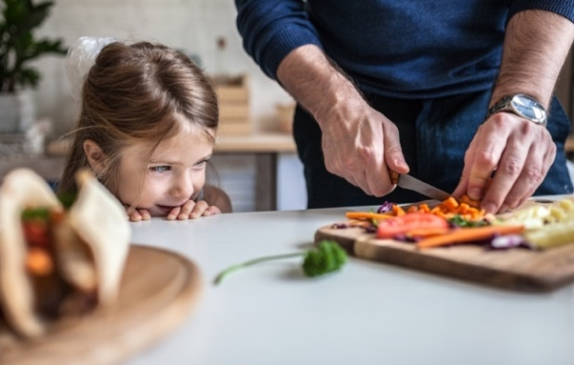

Raw, Roasted, Sautéed
For an easy snack, enjoy raw veggies and dip. Baby carrots, sugar snap peas, and bell peppers are sweet and involve little prep work to take for on-the-go. Hummus or plain Greek yogurt with your favorite spice mix make a tasty dip for vegetables. Create a full meal with just one pan by roasting veggies like broccoli, sweet potatoes, and Brussels sprouts alongside a protein like chicken. It’s an easy clean up plus a tasty dinner!

Sautéing uses heat to cook food in a shallow pan, like a skillet. Green beans, summer squash, and zucchini sauté nicely. Check out this month’s recipe featuring sautéed asparagus!

Vegetables enjoyed in a variety of ways like the ones listed above will have nutritional values that slightly vary between different preparation methods. When cooking, try to limit frying or using heavy cream-based sauces. Eating more vegetables each day is what matters most!

Grow Your Own Vegetables!
The climate in most locations across Texas is great for growing vegetables in your yard or in a container garden year-round! You can grow vegetables from seed or transplants. Transplants will shorten the growing time in your garden and can be purchased from your local nursery or retail store. For help locating, prepping, and establishing a garden site, check with your local county extension agent to learn more about seasonal vegetables and for recommendations on which varieties grow best in your area.

Written by: Lindsey Breunig-Rodriguez, Project Specialist – Better Living for Texans
Content Source: MyPlate Tip Sheet: Vary Your Veggies
Photo From: Microsoft Office

Local Events

Recipe of the Month

Recipe from Lindsey Breunig-Rodriguez, BLT Project Specialist

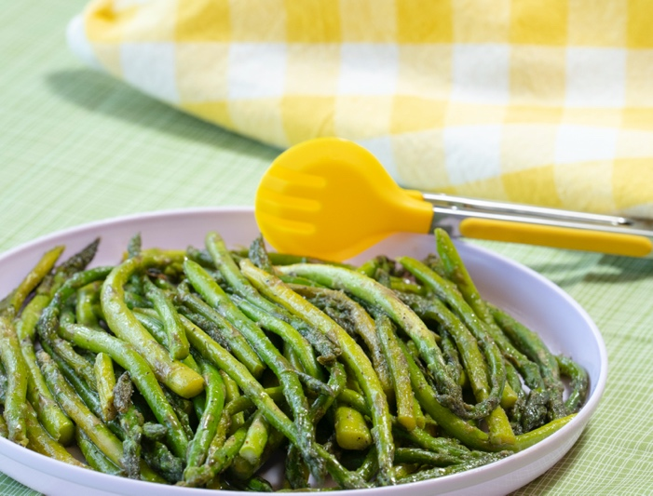
Stovetop Asparagus

Enjoy vegetables in a variety of ways. You can eat them raw, roasted, steamed, or sautéed. Choose these options more often than frying or using heavy sauces.

Ingredients
1 | pound fresh (about 1 bundle) or frozen asparagus
1 | tablespoon oil
¼ | teaspoon salt
¼ | teaspoon black pepper
¼ - ½ | teaspoon garlic powder

Directions
- Rinse fresh asparagus with cool water.
- Remove woody-end pieces of asparagus by cutting ends or snapping off the ends.
Leave whole or cut asparagus spears into thirds.
- Heat a large skillet on medium heat and add oil, asparagus, salt, pepper, and garlic powder.
Cover and cook for 8 to 10 minutes until asparagus is cooked to preferred tenderness.
To prevent burning, stir frequently and add 1 to 2 tablespoons of water as needed.
- Test for tenderness by removing one spear and poking the thickest part with a fork.
If the fork slides in easily, the asparagus is ready.

Nutrients Per Serving: 60 calories, 3.5 g total fat, 0 g saturated fat, 0 mg cholesterol,
150 mg sodium, 5 g carbohydrates, 2 g fiber, 2 g total sugar, 0 g added sugar, and 3 g protein.

Total Cost: $$$$

