March is for National Nutrition Month
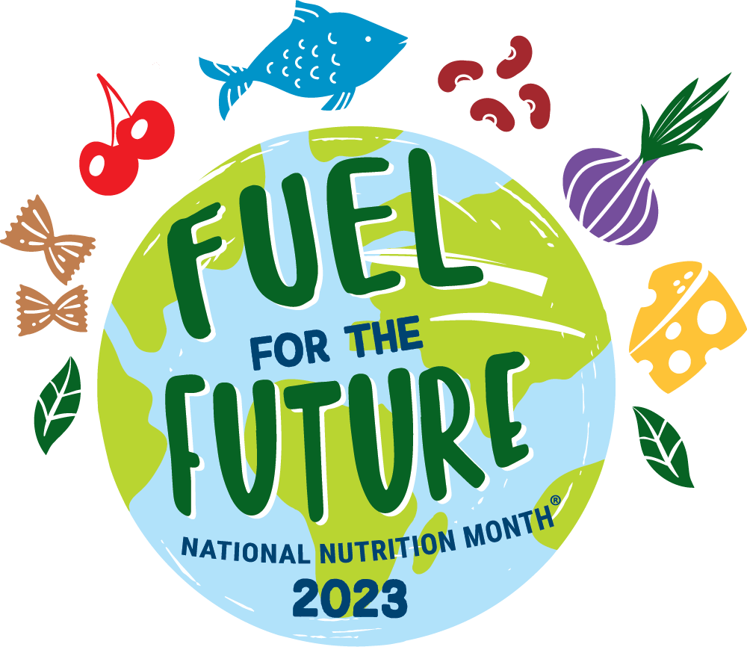
In 1973 the Academy of Nutrition and Dietetics began dedicating the month of March to promote healthy eating habits, informed food choices and the importance of physical activity. The more informed we are, the better we can make decisions for ourselves and our families. This year’s theme is “Fuel for the Future,” which encourages a nourished eating pattern (diet) at every stage of our life while also protecting the environment! Here are some ‘fuel for the future’ key messages!

Eat with the environment in mind.
When planning meals try to choose foods that are in season. Seasonal foods will not only taste better but will likely have ‘traveled’ less distance to your grocery store helping reduce the price.

Grow your own favorite fruits and vegetables! Learn how to start a community, container, or backyard garden with our program series called ‘Growing and Nourishing Healthy Communities Garden Course.’

Stay nourished and save money.
Reduce food waste by planning your weekly meals and snacks. Before shopping, see what food you have at home before buying more and make a grocery list to help limit purchasing unneeded items. Another series, ‘A Fresh Start to a Healthier You!’ can be a great program to learn more about saving money and meal planning.

Eat a variety of foods from all food groups.
Try to eat a variety of foods which include fresh, frozen, canned, and dried options. Avoid fad diets and practice gratitude for your body by giving it the fuel it needs. ‘Get the Facts’ is a program series that provides information to support a healthy and balanced diet.

Make tasty foods at home.
Continue practicing cooking and meal preparation skills and look for creative ways to use leftovers rather than throwing them away. Share foods you have in excess with family and friends while creating happy memories by eating together.

Contact an Extension Agent!
The Better Living for Texans program offers programs for people of all ages with nutrition information that is safe, and realistic for you. Contact an Extension Agent in your county to learn more on how to be fueled for the future!

To learn more about National Nutrition Month visit,
https://www.eatright.org/national-nutrition-month-2023. Get fueled for the future!

Written by: Ingrid Macias, El Paso County Extension Agent – Better Living for Texans
Photo and Source: https://www.eatright.org/national-nutrition-month-2023

Local Events

Recipe of the Month
Recipe and photo from MyPlate Kitchen at MyPlate.gov

Whole Grain Strawberry Pancakes
Whole wheat flour adds a nutty flavor and texture to these great-tasting pancakes. Dish these up with berries and a glass of milk on the side for a wholesome start to your day!
Serves: 7

Ingredients:
1½ | cups whole wheat flour
3 | tablespoons sugar
1 | teaspoon baking powder
½ | teaspoon baking soda
½ | teaspoon salt
3 | eggs
1 | container vanilla low-fat yogurt (6 ounces)
¾ | cup water
3 | tablespoons vegetable oil
1¾ | cups sliced fresh strawberries
1 | container strawberry low-fat yogurt (6 ounces)

Directions:
- Heat griddle to 375°F or heat 12-inch skillet over medium heat. Grease with oil if necessary (or spray with cooking spray before heating).
- In large bowl, mix flour, sugar, baking powder, baking soda and salt; set aside.
- In medium bowl, beat eggs, vanilla yogurt, water and oil until well blended.
- Pour egg mixture all at once into flour mixture; stir until moistened.
- For each pancake, pour slightly less than 1/4 cup batter from cup or pitcher onto hot griddle. Cook pancakes 1 to 2 minutes or until bubbly on top, puffed and dry around edges. Turn; cook other sides 1 to 2 minutes or until golden brown.
- Top each serving (2 pancakes) with 1/4 cup sliced strawberries and 1 to 2 tablespoons strawberry yogurt.

Nutrients Per Serving:
260 calories, 9 g total fat, 0 g saturated fat, 93 mg cholesterol, 390 mg sodium, 36 g carbohydrates, 4 g fiber,
16 g total sugar, 10 g added sugar, and 9 g protein

Total Cost: $$$$

