Important Holiday Food Safety Tips
During the holidays, people gather to enjoy each other and tasty food. To prevent friends and family from getting a foodborne illness, food needs to be prepared safely. Start with the four FightBAC™ basics of food safety.

1. CLEAN: A clean kitchen can help prevent the spread of bacteria. Wash hands with soap and warm water for 20 seconds before and after handling food. Keep utensils, cutting boards, and food-preparation areas clean as you prepare your meal.

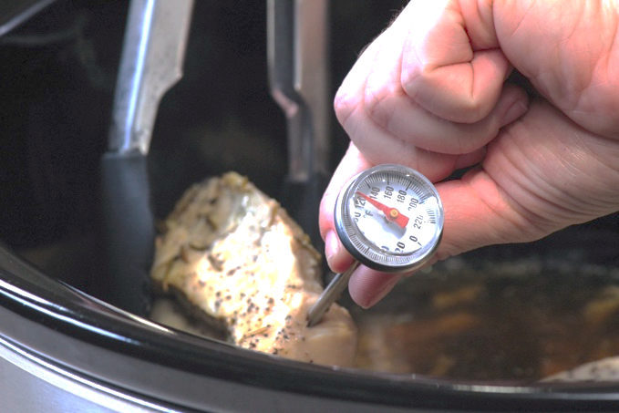
2. SEPARATE: Cross-contamination occurs when bacteria spreads to food from hands, cutting boards, utensils, or other foods such as raw meat and poultry. Use one cutting board for fresh produce and a separate one for cutting raw meat and poultry. Never place cooked food on a plate that held raw meat and poultry unless the plate has been washed thoroughly with hot, soapy water.

3. COOK: Food is safely cooked when it reaches a set internal temperature that kills harmful bacteria. Use a food thermometer to check the food has been cooked to a safe internal temperature. Safe internal temperatures can be
found on the food packaging label or you can see a full list at https://www.foodsafety.gov/food-safety-charts/safe-minimum-internal-temperatures.

4. CHILL: Keep cold foods at 40°F or cooler until it is time to serve them. Your refrigerator temperature should be 40°F or below, and the freezer at 0°F or below. Chill cooked foods quickly by dividing them into shallow containers before placing them in the refrigerator or freezer.

Bacteria grows quickest between 40-140°F, plan to eat food immediately or store safely. Prepared and perishable foods, hot or cold, should not be left out at room temperature for more than 2 hours. Holiday dinners are often buffet-style, which may extend the 2-hour limit. Avoid food being wasted or unsafe by setting out smaller portions while the remaining food is stored safely. Hot foods can be kept warm in an oven set at 200-250°F, and cold foods can remain in the refrigerator. Enjoy leftovers within 2 or 3 days and thoroughly reheat to 165°F before eating. Leftover soups, stews, and gravies should be brought to a boil before serving.

Written by: Andrea Stelting, Central Regional Project Specialist – Better Living for Texans
Source: Keep Foodborne Illness from Spoiling Holiday Parties (NUTR-PU-255)
Photo source: Better Living for Texans (food thermometer being used to check poultry)
Local Events

Recipe of the Month
Recipe from Better Living for Texans and photo from Canva.com

Baked Winter Squash
Winter squash often have a hard skin and flesh (inside). Make preparation easier by poking the skin with a knife and placing in the microwave for 3 minutes. Wait to cool before handling.

Serves: 6
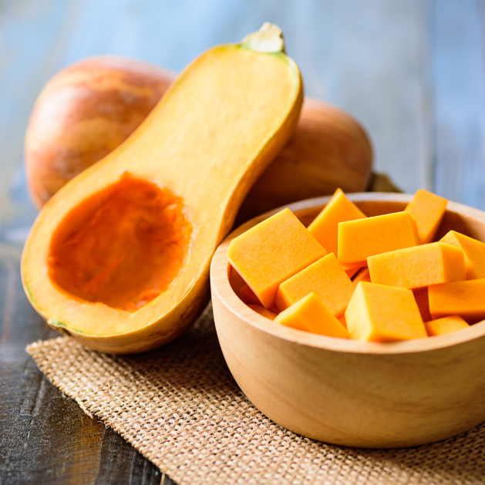
Ingredients:
½ | cup onion, chopped
1 | tablespoon unsalted butter
3 | cups winter squash, cooked and mashed (butternut, acorn, or spaghetti)
½ | cup part skim mozzarella cheese
¼ | teaspoon pepper

Directions:
- Wash your hands and clean your cooking
area. Preheat oven to 400°F.
- Cook onions on low heat with butter
until tender.
- Combine all ingredients and place in a
1-quart baking dish. Bake for 35 to 45 minutes.

Nutrients Per Serving:
80 calories, 4 g total fat, 2 g saturated fat, 10 mg cholesterol, 60 mg sodium,
11 g carbohydrates, 3 g fiber, 4 g total sugar, 0 g added sugar, and 3 g protein

Total Cost: $$$$

