Budget Friendly Holiday Celebrations
Cooking and preparing for holiday celebrations does not have to be stressful on you or your food budget. Use the tips below to help plan and budget for your holiday celebration.

Set a Budget and Plan Meals First
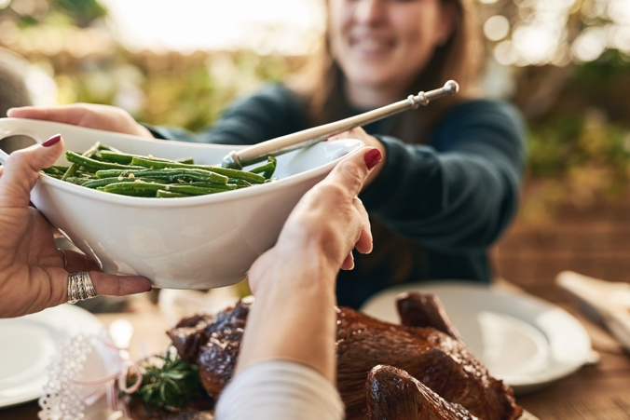
Set a food budget to help meal plan for the specific holiday meal, week, or entire month. Identifying your budget now will help when deciding what food you want to buy. When budgeting and planning, consider nutrition, cost, and convenience/time. For example, a premade sweet potato casserole might be convenient but cost more while preparing your own mashed sweet potatoes will be cheaper but involve additional
prep time at home.

Look at what is already in your pantry or freezer. There may be a few items in the back that could be used for a holiday meal. Remember, the money already spent on this food will be wasted if not eaten before it expires. Using this food as a starting point, you can possibly prepare a full side-dish without needing to buy any extra ingredients.

Make a List and Shop Store Sales
Taking the time to make a list before heading to the store can save you time and money when you get there. Make an initial list of what you need and then rewrite it, putting the items in the order in which you will find them in the store. This can help keep you focused on the items you need and avoid the "extra" tempting items not on your list.

Another way to save money at the grocery store is to use coupons and sales ads. For an additional savings, try to use coupons when foods are on sale. Keep in mind store brands may still be the better buy over name brand items that are
on sale.

Be Creative
Remember the meaning behind the holiday you are celebrating, time spent with friends and family can be priceless and memorable. Consider making the holiday meal a potluck to help divide costs among friends and family and save prep time in the kitchen. Instead of a full meal, consider making new holiday traditions by going on a walk at the local park, or preparing an appetizer for a game night. Time together will still be enjoyed while saving money (and stress) that can come with prepping a full holiday celebration.

Written by Brenda Anderson, Southeast Regional Project Specialist – Better Living for Texans and Lindsey Breunig-Rodriguez, Project Specialist – Better Living for Texans
Source: A Fresh Start to a Healthier You! Texas A&M AgriLife Extension Service Better Living for Texans program and https://extension.umn.edu/save-money-food/holiday-food-budget
Photo: Microsoft.com

Local Events

Recipe of the Month
Recipe and photo source: https://www.myplate.gov/recipes/supplemental-nutrition-assistance-program-snap/mashed-sweet-potatoes

Mashed Sweet Potatoes
Mashed sweet potatoes are an easy and nutritious side dish that can accompany any entree. A great idea to try in place of traditional mashed potatoes.

Serves: 4
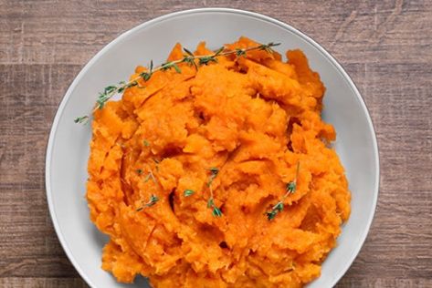
Ingredients:
4 | small to medium sweet potatoes
³/₄ | teaspoon dried thyme  or 3 tablespoons fresh
¹/₄ | teaspoon salt
¹/₄ | teaspoon pepper

Directions:
- Wash, peel, and cut potatoes into slices that are about ³/₄ inch thick.
- Place potatoes in a saucepan with enough water to cover the potatoes.
- Bring the water to a boil on medium heat. Cook the potatoes for 20 to 25 minutes until soft.
- Drain the water and put the potatoes in a medium bowl. Use a fork or potato masher to mash the potatoes. Mix in the thyme, salt, and pepper.

Nutrients Per Serving:
113 calories, 0 g total fat, 0 g saturated fat, 0 mg cholesterol, 217 mg sodium,
26 g carbohydrates, 4 g fiber, 5 g total sugar, 0 g added sugar, and 2 g protein

Total Cost: $$$$

