Healthy Halloween Celebrations!
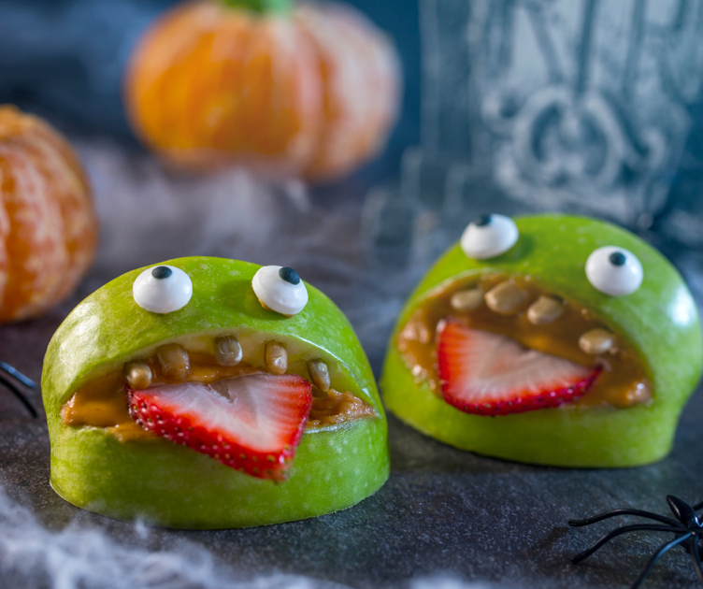
There are many ways to enjoy a sweet and healthy Halloween! This spooky season is often paired with sweet treats and desserts that are high in added sugars. To encourage healthier eating habits, we want to try and enjoy these sweet treats in moderation. Continue reading for some ideas to share with your family for a healthier Halloween celebration!

There are various treat options to pass out on Halloween night! Ideas include mini boxes of raisins, popcorn, or individual snack cracker or trail mix packages. There are even low-cost non-food items like bookmarks, fruit shaped erasers, or stickers that could be passed out to trick-or-treaters. Think of ways to encourage more snack fruits and vegetables and consider setting a limit for how many pieces of candy everyone can have a day or per week. Additionally, offer a healthy snack before enjoying a piece of candy. Healthy snacks can be fun by preparing them with your child’s help and being creative together. Examples include, creating a smiley face with sliced bananas and raisins or using cookie cutters

to make fun and easy shapes. Let children create their favorite trail mix combo with ingredients like dry whole-grain cereal, dried fruit, and unsalted nuts. In addition to snacks, do not forget that sweet treats include soda and other sweetened drinks. Offer water, 100% juice, or fat-free milk when children are thirsty and make soda an occasional treat.

Celebrations and parties
Take advantage of the fun Halloween spirit by trying a new recipe that contains one ingredient you think most of your guests may have never tried before. Guests can pretend to be ‘detectives’ or ‘spies’ as they guess the new ingredient! Include other tasty snacks like whole-grain crackers, vegetables with hummus, or fruit kabobs with low-fat yogurt as a dip or sauce. Other ways to practice moderation are to use smaller plates or bowls for desserts and to share a candy bar or cupcake. Keep the party theme going by dancing to your favorite music and playing active games.

Have a fun, safe, and healthy Halloween!

Written by Brenda Anderson, Southeast Regional Project Specialist – Better Living for Texans
Source: https://www.myplate.gov/tip-sheet/start-simple-myplate
Photo: Canva.com

Local Events

Recipe of the Month
Recipe and photo source: https://www.myplate.gov/recipes/supplemental-nutrition-assistance-program-snap/roasted-pumpkin-seed-snack-mix

Roasted Pumpkin Seed Snack Mix
A quick and tasty snack mix that can be tossed together and enjoyed instantly while you are on the go, no cooking required.
Serves: 8
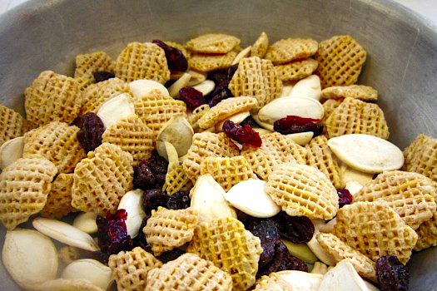
Ingredients:
2 | cups crispy rice or wheat cereal
¹/₂ | cup roasted whole pumpkin seeds
¹/₃ | cup slivered almonds
¹/₂ | cup dried cranberries
2 | cup raisins

Directions:
- Wash hands with soap and water.
- Mix all ingredients together and serve!

Nutrients Per Serving:
199 calories, 11 g total fat, 2 g saturated fat, 0 mg cholesterol, 121 mg sodium,
23 g carbohydrates, 2 g fiber, 11 g total sugar, 4 g added sugar, and 6 g protein

Total Cost: $$$$

