It’s Time for Fall Gardening!
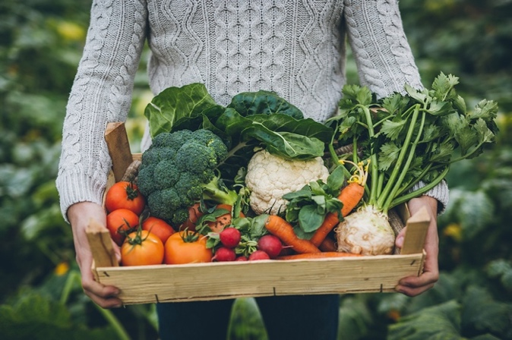
Did you know in most Texas areas the climate is suitable for a fall vegetable garden? Many gardeners will plant vegetables in the spring and early summer and not realize they can also grow vegetables in the fall. For help locating, prepping, and establishing a garden site, which can be used for both fall and spring planting, check out the planning guide on AgriLife Extension’s Easy Gardening series. (https://aggie-horticulture.tamu.edu/vegetable/easy-gardening-series/)

Fall fruits and vegetables are categorized as long- or short-term plants. Some plants may not grow well after the first frost (temperature is below 32°F) and are called frost-susceptible. Other plants may thrive during the cooler season making them frost-tolerant. Group long- or short-term plants together according to their frost tolerance.

Plant short-term, frost-susceptible plants together—they will not survive a frost. Examples include beans, cantaloupe, corn, cucumbers, eggplant, okra, pea, peppers, Irish potatoes, sweet potatoes, squash, tomatoes, and watermelon.

Plant long-term, frost-tolerant plants together. Examples include beets, broccoli, Brussels sprouts, cabbage, carrot, cauliflower, chard, collard, garlic, kale, lettuce, mustard, onion, parsley, spinach, and turnip.

There are many varieties of fruits and vegetables; however, only three or four varieties may grow well in your county or region. Use Aggie Horticulture’s Vegetable Variety Selector to help identify what grows best in your area. (https://aggie-horticulture.tamu.edu/publications/veg_variety/)

You can grow fruits and vegetables from seed or transplants. Transplants will shorten the growing time in your garden and are recommended in the fall when growing tomatoes, peppers, and eggplants or cold-friendly broccoli, cauliflower, and cabbage. Transplants can also be purchased from your local nursery or retail store.

Don’t forget to enjoy your garden! Visit your garden regularly to see growth and changes, and to harvest produce when ready. For more information reach out to your AgriLife Extension County Extension Agent!

Written by Michele Scaife, Extension Agent – Better Living for Texans
Source: https://agrilifelearn.tamu.edu/s/product/fall-vegetable-gardening-guide/01t4x000004Ofit
Photo: Microsoft Image

Local Events

Recipe of the Month
Recipe and photo source: https://www.myplate.gov/recipes/supplemental-nutrition-assistance-program-snap/flavorful-fried-rice

Flavorful Fried Rice
Peas and carrots can grow abundantly in your fall vegetable garden. Use brown rice for extra fiber.
Serves: 6

Ingredients:
2 | tablespoons cooking oil (or margarine) | 4 | eggs
1 | cup rice, uncooked | 4 | egg whites
3 | tablespoons minced onion | ¼ | cup non-fat milk
½ | cup carrots, chopped or grated | ½ | cup peas
2 | cups water | 2 | tablespoons low sodium soy sauce
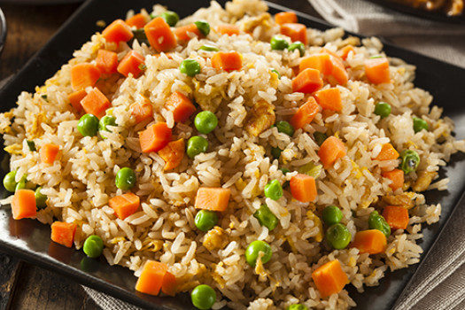
Directions:
- In a frying pan over medium heat, cook rice, minced onion, and carrots in oil, stirring often until lightly browned.
- Slowly add water, reduce heat, cover, and simmer until liquid is absorbed and rice is tender, about 20 minutes.
- Beat eggs in a bowl and stir in milk, peas, and soy sauce. Pour over hot rice mixture. Cook on medium heat, stirring often until eggs are firm.

Nutrients Per Serving:
237 calories, 8 g total fat, 1 g saturated fat, 124 mg cholesterol, 393 mg sodium, 30 g carbohydrates,
1 g fiber, 2 g total sugar, 0 g added sugar, and 11 g protein

Total Cost: $$$$

