Get Healthy with MyPlate!
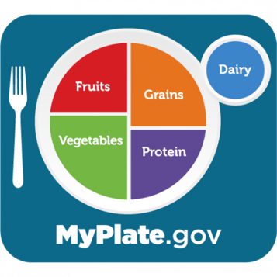
Social media and television constantly have advertisements that highlight ‘nutrition gurus’ or sell magic pills for better health. It can be overwhelming trying to decide what advice to follow; however, finding accurate information can be easier if you focus on trusted sources with information based on scientific research. One trusted source for nutrition and physical activity recommendations is MyPlate.gov.

What is MyPlate?
To help Americans achieve better health, the U.S. Department of Agriculture created MyPlate which is a tool used to teach Americans about dietary recommendations and healthy eating. MyPlate is represented by a colorful plate that is divided into the five food groups.

What are MyPlate recommendations?
General food group recommendations for people 14 years of age and older eating 2,000 calories a day are:
- 2 cups fruit: Focus on fruits that are fresh, frozen, canned, 100% juice, or dried.
- 2½ cups vegetables: Choose from fresh, frozen, and canned vegetables. Include colorful varieties like dark green, red, and orange vegetables.
- 6 ounces grains: Make half your grains whole grains. Find whole-grain foods by looking at the product’s ingredients list.
- 5½ ounces protein: Protein foods include seafood; beans, peas, and lentils; unsalted nuts and seeds; soy products; eggs; and lean meats,, and poultry.
- 3 cups dairy: Choose low-fat or fat-free dairy milk or yogurt (or lactose-free dairy or fortified soy versions).

What else is recommended?
Choose foods and beverages with less added sugars, saturated fat, and sodium. Try to limit:
- Added sugars to less than 50 grams a day.
- Saturated fat to less than 22 grams a day.
- Sodium to less than 2,300 milligrams a day

Adults should try to do 150 to 300 minutes a week of moderate-intensity aerobic activity and at least two days a week of muscle-strengthening activities. Children and adolescents should do 60 minutes or more of moderate-to-vigorous physical activity daily, and at least three days a week should include muscle-strengthening activities.

Where can I find more information?
Visit MyPlate.gov to find individualized food plans, goal setting and tracking resources, delicious recipes, food budgeting tips, and many more nutrition resources. Remember that small daily changes lead to habits, and healthy habits lead to long term health!

Written by Ingrid Macias, Extension Agent - Better Living for Texans
Content Source: https://www.myplate.gov/myplate-plan/results/2000-calories-ages-14-plus
Photo Source: https://www.myplate.gov/resources/graphics/myplate-graphics
Local Events

Recipe of the Month
Recipe and photo source: MyPlate Kitchen, https://www.myplate.gov/myplate-kitchen

Avocado and Corn Salsa
The avocado and corn are given a flavor boost with the fresh cilantro and lime. Try this salsa with baked chicken for an easy weekday meal.
Serves: 5
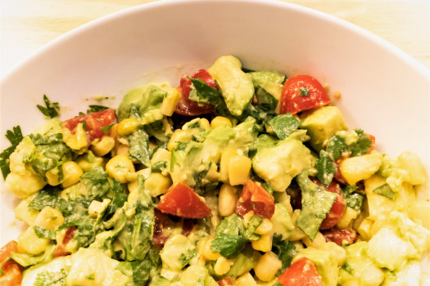
Ingredients:
1 | diced avocado
¾ | cup frozen corn kernels, thawed
½ | cup grape tomatoes, quartered
1 | tablespoon cilantro, chopped
2 | teaspoon lime juice
¼ | teaspoon salt

Directions:
- Toss avocado, corn, tomatoes, cilantro, lime juice and salt in a medium bowl.
- Chill one hour and then serve.

Nutrients Per Serving: 67 calories, 4 g total fat, 1 g saturated fat, 0 mg cholesterol, 119 mg sodium, 8 g carbohydrates, 3 g fiber, 1 g total sugar, 0 g added sugar, and 1 g protein

Total Cost: $$$$

