Gardening with Children
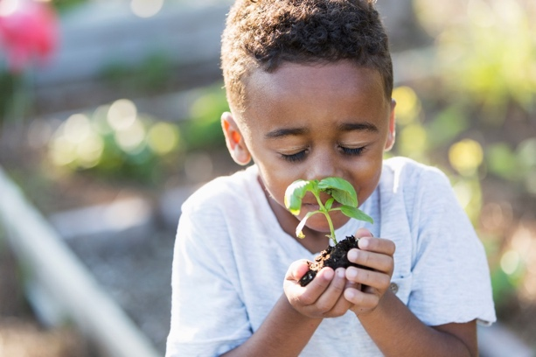
Getting children to eat healthy can be challenging; however, gardening can be a fun and inexpensive way to spark children’s curiosity in trying vegetables and fruits. The Texas A&M AgriLife Extension Service is available to help and teach you about what grows best in your area and make your family’s experience a positive one. Recipients of the Supplemental Nutrition Assistance Program (SNAP) can use their food assistance benefits to purchase food-producing seeds and plants to grow their own food. Let us dig-in to find out more!

Do your research
Before getting your children completely involved do a little research to find the best times to plant various vegetables and fruits in your area. Consult your local county extension office for advice. Visit https://counties.agrilife.org/ to locate your local county extension office or you can learn more at https://aggie-horticulture.tamu.edu/vegetable/.

Involve your children in the process
Gardening creates hands-on experiences for children that creates interest and to try fruits and vegetables they might not have previously been given. Include your children in the process of choosing a location, helping decide what to plant, planting the seeds in the soil, watering the seeds, and ensuring plenty of sunlight reaches the plants.

Look for a space that is mostly sunny and not directly in the shade. You can plant your seeds and transplants directly in-ground, in a raised bed, or in a container like a pot or recycled 5-gallon bucket. Make sure soil is soft enough for your children to handle whether it is with their hands, shovel, or spade. Children can get their hands dirty by helping mix in compost! Other tasks your child can do include digging, pushing a cart while shopping, filling pots and garden bags, carrying and using a watering can or hose, picking ripe tomatoes and peppers, or tasting the produce.

Your child will be excited to watch the changes in the plant and see the vegetable or fruit develop into a tasty and nutritious food! Also, your child will have an appreciation of where their food comes from and what it takes to produce it. As you are getting started, keep it simple and start small.

Use your SNAP benefits
SNAP recipients can maximize their produce purchasing power when they use their Electronic Benefits Transfer (EBT) card to buy food-producing plants and seeds to grow a garden of their favorite vegetables and fruits. To take the guess work out of finding authorized SNAP retailers, there is a SNAP Retailer locator at https://www.fns.usda.gov/snap/retailer-locator.

Written by Wendy Hamilton, Extension Agent - Better Living for Texans
Content Source: https://www.naeyc.org/our-work/families/7-tips-vegetable-gardening, https://www.canr.msu.edu/news/use_your_snap_benefits_to_grow_a_garden, and www.JMGkids.us/LGEG
Photo Source: https://www.istockphoto.com/photo/little-boy-in-garden-smelling-fresh-herbs-gm517446415-49107296
Local Events

Recipe of the Month
Recipe and photo source: Junior Master Garden Kitchen, https://jmgkids.us/gardenkitchen/

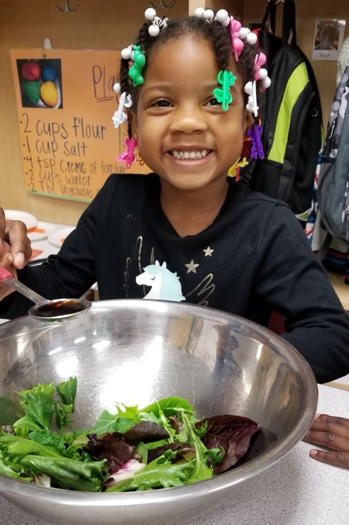
Red Leaf Lettuce and Strawberry Salad
How the children can help: wash the produce, measure the ingredients, combine the dressing ingredients, shake the dressing, and drizzle the dressing over the salad.
Serves: 4

Ingredients:
Dressing*
¹/₃ | cup of vegetable oil
3 | tablespoons of vinegar
2 | tablespoons of honey
1 | teaspoon of mustard
¹/₈ | teaspoon of salt
¹/₈ | teaspoon of cinnamon
*Optional: substitute ¹/₂ cup of balsamic
vinaigrette or another low-fat dressing
Salad
4 | cups of red leaf lettuce greens
¹/₄ | pound of strawberries, sliced (about 1 cup)

Directions:
- Wash your hands and clean your cooking area.
- In a small jar with a tight-fitting lid, combine the oil, vinegar, honey, mustard, salt, and cinnamon. Cover the jar and shake it well. If no jar is available, blend the ingredients in a bowl with a fork. Chill the dressing until it’s time to serve it.
- Rinse and cut the leafy tops off the strawberries and slice them lengthwise into fourths.
- Place the red leaf lettuce greens in the colander and run water over them. Drain them and pat them dry.
- In a large mixing bowl, combine the lettuce and sliced strawberries. Toss them gently.
- Drizzle the dressing over the salad as desired.

Nutrients Per Serving: 210 calories, 19 g total fat, 2 g saturated fat, 0 mg cholesterol, 95 mg sodium,
13 g carbohydrates, 1 g fiber, 11 g total sugar, and 1 g protein

Total Cost: $$$$

