Gather Around the Table
Summertime is near which often brings a sigh of relief as schedules become less hectic. Take advantage of this extra time with family mealtime! Researchers have discovered when families eat together, adults and children eat more fruits and vegetables, have a balanced diet, and eat less fast food. Family mealtimes can also increase closeness within the family, and children do better in school and have fewer behavior problems. There are many ways to view family. If you are single or an empty nester, include friends or neighbors in your mealtime.

Tips for family mealtimes
Keep it simple: Meals can be quick, easy, and prepared with few ingredients. Try including a food from each food group on MyPlate (fruits, vegetables, grains, protein, and dairy) and limit highly processed and fried foods.

Start small: Start with one- or two-family meals a week. Communicate with family members when and where the meal will take place. Studies have found the benefits of family mealtime continue to increase with more meals together.

It does not have to be dinner: Family schedules can be crazy. If dinner does not work for your family, try other meals like breakfast, lunch on the weekend, or a snack together.

Get everyone involved: You do not have to prepare the meal alone! Plan menus and pick recipes as a family. Assign everyone different tasks to help. For example, young children can set the table, and older kids can prepare a side dish or a salad. If you are eating with other adults, make it a potluck!

Keep it light: Family mealtime is not the time to argue, discuss poor school grades, or other topics that might upset one another. Use these meals to strengthen relationships and create an inviting atmosphere! While eating, ask everyone to share something interesting about their day or week. Keep the TV off and phones away from the table!

Make it fun: Besides having fun conversations, add excitement with food themes. Pick out a theme, like a taco night or Italian food. Take the meal outside with a family picnic or stay inside with a blanket on the floor in your living room!

Written by Tracie Estepp, Extension Agent - Better Living for Texans
Content Source: https://www.eatright.org/food/nutrition/eating-as-a-family/family-meals--small-investment--big-payoff, https://thefamilydinnerproject.org/about-us/benefits-of-family-dinners/, and
https://www.nytimes.com/guides/well/make-most-of-family-table
Photo Source: Canva.com
Local Events

Recipe of the Month
Recipe and photo source: MyPlate Kitchen, https://www.myplate.gov/myplate-kitchen

Any Days a Picnic Chicken Salad
Onion and pickle relish spice up a traditional chicken salad.
Serves: 6
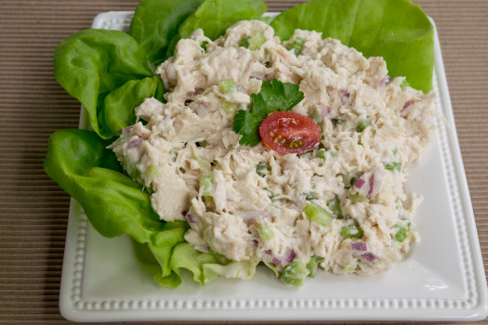
Ingredients:
2½ | cups cooked and chopped chicken breast
½ | cup chopped celery
¼ | cup chopped onion
1 | tablespoon pickle relish
½ | cup light mayonnaise

Directions:
- Wash hands with soap and water.
- In a bowl, combine all ingredients. Keep refrigerated until ready to serve.
- Use chicken salad for sandwiches and pasta salad (mix with 2 cups cooked pasta). Also enjoy it served in a tomato, lettuce, or cucumber boat.
- Chicken salad does not freeze well, use within one to two days.

Nutrients Per Serving: 150 calories, 7 g total fat, 1 g saturated fat, 58 mg cholesterol,
497 mg sodium, 5 g carbohydrates, 0 g fiber, 3 g total sugar, 2 g added sugar, and 17 g protein

Total Cost: $$$$

