Celebrating Cultures through Food
Every year during the month of March the Academy of Nutrition and Dietetics celebrates National Nutrition Month. This year’s theme is “Celebrate a World of Flavors,” and focuses on celebrating foods and flavors from different cultures all around the world.

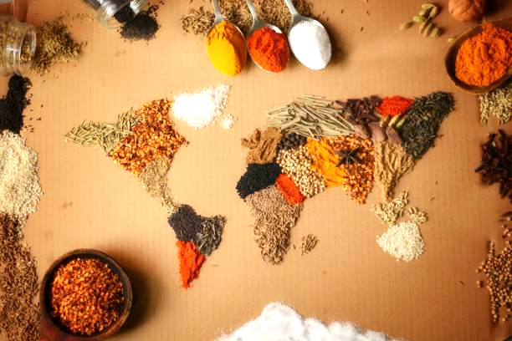

Think about a family recipe that has been passed down from generation to generation. Positive memories are often associated with our family meals or ingredients. At its most practical form, food provides our body with nutrients to go and stay healthy; however, food can be an expression of our cultural identity. Our favorite dishes, ingredients, spices, or cooking methods can represent traditions, beliefs, and practices from a variety of different regions, ethnicities, and religions.

Traditionally, cultural foods have been considered unhealthy; however, we know there are a variety of foods available to us that are tasty and nutritious for our bodies. The 2020-2025 Dietary Guidelines for Americans provide a framework that gives each of us the space to adapt our diet as needed based on personal preferences, medical history, budget, and culture. Rather than omitting cultural foods that you love, think about how to make them healthier with these suggestions.

- Be mindful of portion sizes and eat a variety of whole grains, fruits and vegetables, protein, and dairy.
- Eat more unsaturated fats like olive or canola oil, avocados, nuts, and seeds.
- Use a variety of cooking methods like steaming, baking, roasting, and barbequing. These cooking methods use less fat compared to frying.
- Reduce salt and sugar intake by using different spices and herbs. Examples include chili powder, curry powder, nutmeg, lemongrass, and cilantro which can be found at many grocery stores.

From Japanese cuisine to a West-African dish or Tex-Mex Tacos and Soul Food, remember there is room at the table for all types of food! This month Celebrate a World of Flavors and try a new food that may be less familiar to you!

Written by Christina Fakhoury, Extension Agent – Better Living for Texans
Content Source: https://www.eatright.org/food/resources/national-nutrition-month and https://www.dietaryguidelines.gov/sites/default/files/2020-12/DGA_2020-2025_CustomizingTheDietaryGuidelines.pdf
Photo Source: https://www.istockphoto.com/photos/spices-of-the-world

Local Events

Recipe of the Month
Adapted recipe and photo source: https://www.myplate.gov/myplate-kitchen

Argentinean Grilled Steak or Chicken with Salsa Criolla
Enjoy a flavorful homemade Argentinean-style Salsa Criolla with your favorite grilled meat!
Serves: 4

Ingredients:
For the Salsa Criolla:
1 | tomato, finely chopped, remove seeds | ¹/₂ | teaspoon minced garlic
¹/₄ | cup finely chopped red onion | ¹/₄ | teaspoon ground oregano
2 | tablespoons fresh chopped parsley | ¹/₈ | teaspoon low sodium adobo seasoning
2 | teaspoons olive oil | ¹/₈ | teaspoon crushed red pepper
2 | teaspoons red wine vinegar |  | 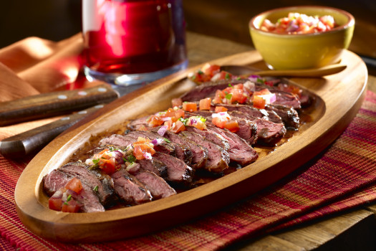  Fun fact: Season blends can vary from culture to culture! Adobo seasoning may include garlic, onion, black pepper, oregano, cumin, and red pepper powder.
For the meat:
1 | pound skirt steak or thinly sliced chicken breasts
¹/₈ | teaspoon low sodium adobo seasoning
Directions:
1. In a small bowl mix all salsa ingredients. Cover and refrigerate for at least 1 hour or up to 48 hours.
2. Lightly grease grill grates and turn grill to medium-high heat. Sprinkle adobo seasoning on both sides of the chosen meat. Grill meat until desired color and proper internal temperature is met (beef 145 °F, chicken 165 °F).
3. Thinly slice meat and top with Salsa Criolla.

Nutrients Per Serving (for steak): 220 calories, 11 g total fat, 4 g saturated fat, 70 mg cholesterol,
80 mg sodium, 5 g carbohydrates, 1 g fiber, 3 g total sugar, 0 g added sugar, and 25 g protein

Total Cost: $$$$

