Energy Booster: SNACKS!
Many adults and youth snack during the day. A quick snack can provide our bodies with a boost of energy between meals. There are a variety of energy boosting snacks available; however, when we are hungry it is easy to reach for less healthy snacks like chips, candy bars, and sodas. While these snacks might be tasty, we want to enjoy them in moderation as these items are often high in added sugars and sodium which when overconsumed can negatively affect our health. Our time may feel limited during the day, but proper planning can help fit healthy snacks into our daily meal plan!

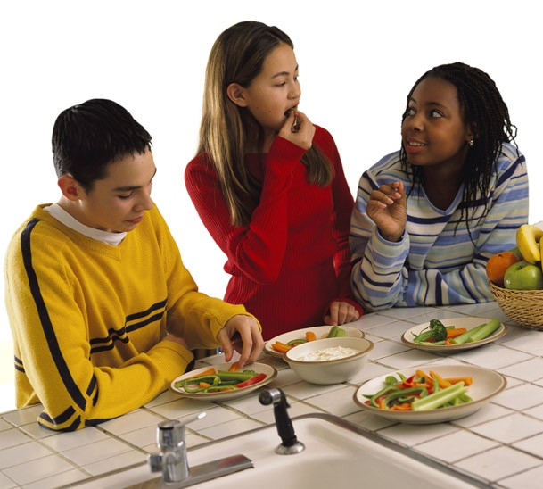

When planning a snack, try to incorporate several MyPlate food groups which are fruits, vegetables, low-fat dairy, lean protein, and whole grains. Including a variety of food groups will help satisfy and curb your hunger for longer. Additionally, compare the nutrition facts label and look to select snacks low in saturated fats, added sugars, and sodium. By reading the label you can see if an item is low or high in a specific nutrient by looking at the Percent Daily Value (DV). A DV
at or below 5% is considered a low source of the specific nutrient listed for one serving. You can learn more here https://youtu.be/s5zroZfMn0I. In Need of more ideas on how to pack some energy boosting snacks? Check out these snack tips!

Snack Tips:
- Add snacks into your meal plan and grocery list. Think about ingredients that might be left over from breakfast, lunch, or dinner that can be used for snacks.
- Wash and prepare fruit and vegetables and pre-portion other snack ingredients the night before.
- Keep healthy snacks within reach to avoid spending extra money at vending machines.
- Tasty low-fat dairy options can include yogurt or string cheese. Great pairings include berries with yogurt or whole grain crackers with cheese.
- Substitute beverages with high amounts of added sugar for water, 100% fruit juice, sparkling water with fruit, or unsweet tea.
- Enjoy some extra flavor and protein by dipping fruits or vegetables into hummus or nut butter.
- Freeze grapes or blueberries for a quick, sweet, refreshing snack. Or satisfy a crunchy and salty craving with popcorn or homemade trail mix.

Written by Sarah Ashley Pisquiy, Extension Agent - Better Living for Texans
Content Source: https://www.heart.org/en/healthy-living/healthy-eating/add-color/healthy-snacking
Photo Source: https://snaped.fns.usda.gov/photo-gallery/three-teens-share-snack
Local Events

Recipe of the Month
Recipe and photo from: Kids Get Cookin’! Fast and Fun Recipes, California Department of Public Health (CDPH) - Nutrition Education and Obesity Prevention Branch (NEOPB)

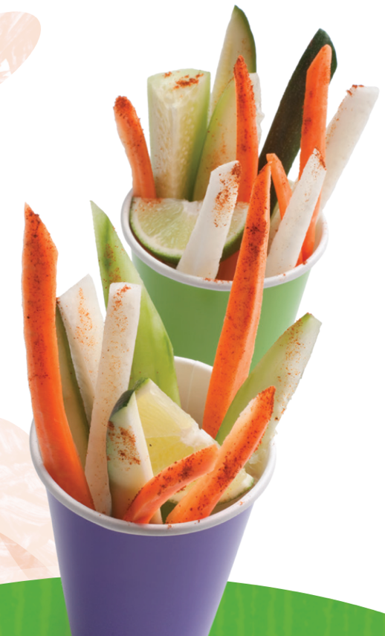
Vegetable Sticks with Chili and Lime
Lime and chili powder taste great on many fruits like cantaloupe, honeydew, watermelon, pineapple, strawberries, mangos, and orange too!
Serves: 4

Ingredients:
1 | cucumber, peeled and cut into sticks
1 | small jicama, peeled and cut into sticks
1 | medium zucchini, cut into sticks
1 | carrot, peeled and cut into sticks
2 | tablespoons lime juice
¼ | teaspoon salt
¼ | teaspoon chili powder
 | dash cayenne pepper (optional)

Directions:
- In a medium bowl combine jicama, cucumbers, zucchinis, carrots, and lime juice.
- In a small bowl, combine salt, chili powder, and cayenne pepper (optional). Sprinkle over cut vegetable sticks.
- Put vegetable sticks onto a plate or in cups and enjoy!

Nutrients Per Serving: 35 calories, 0 g total fat, 0 g saturated fat, 0 mg cholesterol, 170 mg sodium, 7 g carbohydrates, 3 g fiber, 3 g total sugar, 0 g added sugar, and 1 g protein

Total Cost: $$$$

