Stay Safe with Fight BAC!

We cannot see or smell bacteria that can make us sick. To help keep your family safe and reduce your risk of a foodborne illness use the four principles of Fight BAC!

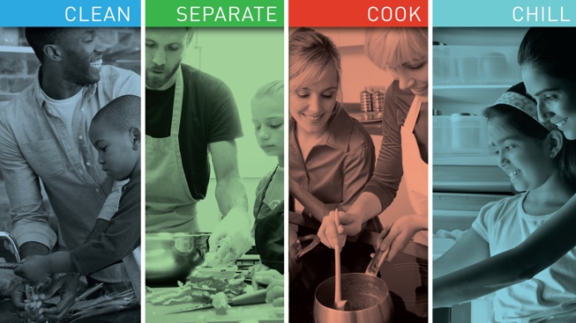

1. Clean
Wash hands with warm water and soap for twenty seconds. All counter tops and equipment should be cleaned before and after food preparation. Keep your refrigerator clean with hot water and soap, and dry with paper towels. Before using, rinse all fruits and vegetables under cold running water even if the peel will be thrown away.

2. Separate
To prevent bacteria from spreading, separate any raw uncooked food (raw meat, poultry, seafood, and eggs) from other foods. When shopping, prevent leaks or cross-contamination by keeping food items separate from other items in your shopping cart and by bagging items separately when checking out. When using a cutting board, keep fresh produce separate from raw meats, seafood, or eggs. If available, use two cutting boards.

3. Cook
Use a food thermometer while cooking your family’s meal to ensure your food is cooked to the proper temperature. Cooking food to the proper temperature ensures that harmful bacteria is destroyed in the cooking process. Check food packaging for safe internal temperatures.

4. Chill
Limit growth of bacteria by keeping your refrigerator set at 40°F or below. All perishable food or leftovers should be either frozen or placed in the refrigerator within 2 hours of purchase or use. Do not overstuff the refrigerator to avoid changes in the proper temperature. The safest way to thaw food is by placing the item in the refrigerator on a plate or dish to catch any juices that might leak out. Never thaw food by leaving on the counter for more than 2 hours.

By using the Fight BAC! principles of clean, separate, cook and chill you can help keep your family safe from a foodborne illness!

For more information visit: https://www.fightbac.org/food-safety-basics/the-core-four-practices/

Written by Wendy Hazzard, County Extension Agent – Family and Community Health
Content Source: https://www.fightbac.org/food-safety-basics/the-core-four-practices/
Photo Source: https://www.fda.gov/food/consumers/food-safety-education-month
Local Events

Recipe of the Month
Recipe and photo source: MyPlate Kitchen, https://www.myplate.gov/myplate-kitchen

Easy Chicken Pot Pie
Leftover chicken and frozen veggies help this chicken pot pie come together quickly.
Serves: 6
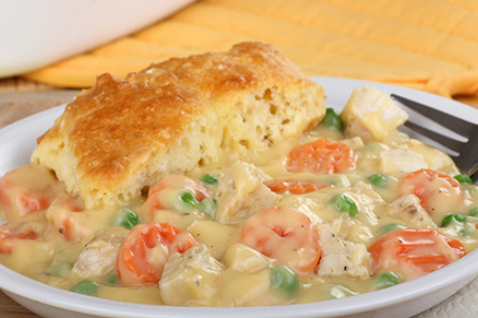
Ingredients:
1 ²/₃ | cups thawed frozen mixed vegetables
1 | cup cut-up cooked chicken
1 | can low-fat cream of chicken soup
1 | cup reduced-fat baking mix
¹/₂ | cup non-fat milk
1 | egg

Directions:
1. Wash hands and any cooking surfaces
2. Pre-heat oven to 400°F
3. Mix vegetables, chicken, and soup in an ungreased, 9-inch pie plate
4. Stir remaining ingredients in a mixing bowl with fork until blended
5. Pour mixture over vegetables and chicken in pie plate
6. Bake 30 minutes or until golden brown
7. Let cool for 5 minutes and serve

Nutrients Per Serving: 189 calories, 4 g total fat, 0 g saturated fat, 55 mg cholesterol,
716 mg sodium, 26 g carbohydrates, 3 g fiber, 9 g total sugar, 5 g added sugar, and 13 g protein

Total Cost: $$$$

