‘Tis the Season for Good Nutrition

Ending the year on a healthy note can be a challenge for many. From the continuous chocolate advertisements on television to the delicious aromas of baked goods at your local grocery store, temptation to overindulge is around every corner. Below are some simple ideas to maintain a balanced diet and still celebrate with flavor.

1. Slice Up Those Vegetables!
Start holiday gatherings by filling your plate with more vegetables. Dark, leafy greens and broccoli are especially delicious this time of year and they will leave you feeling satisfied due to their high amounts of fiber.

2. Keep it Homemade
Cooking a holiday dish rather than buying a prepared meal allows for you to control what goes on your plate. Have the family join in on the kitchen fun by choosing recipes together.

3. Limit Added Sugar
Sweeten up the dessert menu with fruit. Seasonal favorites such as apples, oranges, cranberries, and pomegranates are filled with nutrients, and will satisfy your sweet tooth. When buying canned goods like pumpkin or yams, read the nutrition label to check that there is very little, to no added sugar. Avoid overconsuming sugar sweetened beverages and opt for unsweet tea, infused fruit water, or apple cider with 100% fruit juice.

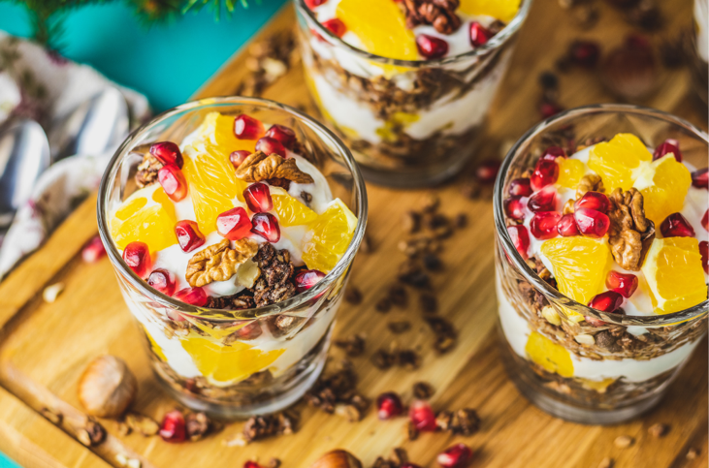

4. Choose Low Sodium Options
When creating casseroles, soups, or gravy, choose low sodium chicken, beef, or vegetable stock. Add flavor by using herbs and spices like thyme, oregano, sage, and garlic. These ingredients are a wonderful way to avoid high sodium intake while keeping dishes savory.

5. Lastly, Enjoy Yourself!
Do not feel discouraged when enjoying a family favorite meal. Celebrating with family usually involves a table filled with delicious food. Enjoy it mindfully and end the year feeling great!

Written by Natalie Ramos, Extension Agent - Better Living for Texans
Content Source: http://cceonondaga.org/nutrition-health/healthy-for-the-holidays
Photo source: http://www.first5coco.org/blog/2011/12/15/have-a-happy-and-healthy-holiday/
Local Events

Recipe of the Month
Recipe and photo source: MyPlate Kitchen, https://www.myplate.gov/myplate-kitchen

Apple Cranberry Salad Toss
Enjoy the flavors with this sweet and tart green salad. Light yet crisp!
Serves: 8
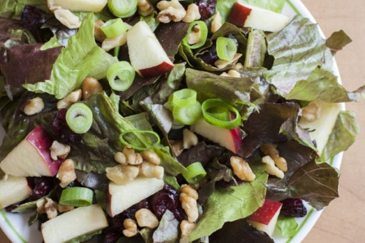
Ingredients:
10 | cups of chopped lettuce, about 1 head
2 | sliced apples
½ | cup chopped walnuts
1 | cup dried cranberries
½ | cup sliced green onions
¾ | cups vinaigrette dressing

Directions:
1. In a large bowl, toss lettuce, apples,
walnuts, cranberries, and onions.
2. Add dressing and toss to coat.
3. Serve immediately.

Nutrients Per Serving: 174 calories, 10 g total fat, 1 g saturated fat, 0 mg cholesterol,
227 mg sodium, 22 g carbohydrates, 3 g fiber, 17 g total sugar, 9 g added sugar, and 2 g protein

Total Cost: $$$$

