Use the Texas Heat to Prep Your Garden!

During July, Texas is extremely hot and it just gets hotter as summer progresses. If you like to garden, you have likely discovered that very few vegetables grow during these hot Texas months. So why fight with Mother Nature when you can use the heat to your advantage?
Soil Solarization
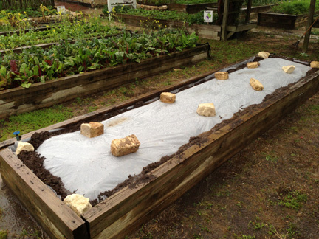
Soil solarization is a chemical free way to kill weed seeds, insects, and insect eggs in between planting times. It is easy, inexpensive, and
best of all, it uses the free summer heat that is so abundant in Texas!
This method of preparing a garden can be used on almost any size of garden from a small raised bed garden to a large commercial operation. To start, clear the garden area of grass, plants, and weeds and then wet the area very deeply with water. Next, cover the plot with a clear or light-colored plastic sheet (such as 1 to 4 mil painter’s plastic) or a tarp, both of which can be found at the local hardware store. Make sure that the edges of the plastic are tucked under a little bit of soil around the edges. Rocks or bricks could also be used to keep the edges down against the ground so the heat doesn’t escape. This will also help keep the wind from blowing the plastic away or out of place.
Depending upon where you live in Texas, the temperature under the plastic can get up to 160 degrees! Start the soil solarization process at least four weeks before you plan on starting your Fall garden. It is important to leave the plastic on the moist garden area for four weeks to completely kill the undesirable seeds and insects. When the plastic is removed, the ground should be moist and bare of weeds, grass, and insects. The heat and steam that forms under the plastic kills all organisms, including good things the plants may need. It is a good idea to apply a bit of compost or fertilizer to the garden area after solarization. The solarization process can be done with in-ground gardens as well as raised bed gardens.
Okra is about the only vegetable that loves to grow in Texas gardens in July and August. So while the okra is growing and the rest of the garden is undeveloped, try preparing the garden for Fall season planting by solarizing the soil.
Written by Kathleen McCown, Extension Agent - Better Living for Texans
Content Source: https://agrilifeextension.tamu.edu/library/gardening/soil-solarization https://snaped.fns.usda.gov/seasonal-produce-guide/okra Photo source: https://jmgkids.us/solarizingyourgarden/

Local Events

Recipe of the Month
Source: Kathleen McCown

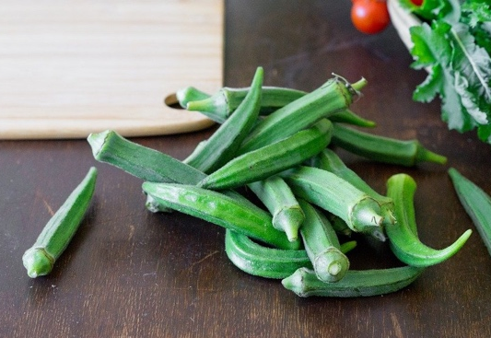
Grilled Okra
Servings: 1

Ingredients
1 | cup raw, fresh whole okra  salt and pepper, to taste

Directions
Photo source: pixabay.com
- Heat up your grill (medium high to high heat).
- Wash whole, fresh okra.
- When the grill is hot, lay the okra on the grill.
- Take them off when they are toasty.
- Season to taste and eat them up! They make great finger food appetizers!!

Nutrients Per Serving: (1 cup) 33 calories, 0 g total fat, 0 g saturated fat, 0 g cholesterol, 2 g protein, 8 g carbohydrates, 3 g dietary fiber, 2 g total sugars, 0 g added sugar, and 7 mg sodium

Total Cost per serving: $$$$

