Physical Activity for Life

Have you ever heard the saying “an ounce of prevention is worth a pound of cure?” According to the Center for Disease Control and Prevention (CDC), physical activity can prevent one in ten premature deaths. Physical activity can help maintain and improve your health, however, studies show that only half of adults get the amount of physical activity that they need to prevent chronic diseases.
There are benefits for getting the recommended amount of physical activity across the life span. In children, it can reduce the risk of depression, improve bone health, and improve attention. For adults, physical activity lowers the risk of high blood pressure and stroke and reduces arthritis symptoms. Benefits for older adults include improved balance, improved joint mobility, and reduced risk of falling.
Recommendations by Age
Preschool-aged Children (ages 3-5 years)
- Physical activity every day throughout the day
- Active play through a variety of enjoyable physical activities
Children and Adolescents (ages 6-17 years)
- 60 mins (one hour) or more of moderate-to-vigorous intensity physical activity daily
Written by Cory Edwards, Extension Agent - Better Living for Texans
Content and Photo Source: Centers for Disease Control, health.gov
- A variety of enjoyable physical activities
- As part of the 60 minutes, on at least three days a week, children and adolescents need:
- Vigorous activity such as running or soccer
- Activity that strengthens muscles such as climbing or push ups
- Activity that strengthens bones such as gymnastics or jumping rope
Adults (ages 18-64 years)
- At least 150 minutes a week of moderate intensity activity such as brisk walking
- At least two days a week of activities that strengthen muscles
- Aim for the recommended activity level but be as active as one is able
Older Adults (ages 65 years and older)
- At least 150 minutes a week of moderate intensity activity such as brisk walking
- At least two days a week of activities that strengthen muscles
- Activities to improve balance such as standing on one foot
- Aim for the recommended activity level but be as active as one is able

Local Events

Recipe of the Month
Source: MyPlate Kitchen
Honey Milk Balls
Servings: 20 balls
Honey milk balls make a great afternoon snack – packed with protein and calcium. They taste like a treat, so be sure to save a few for yourself.

Ingredients
¼ | cup honey
¼ | cup peanut butter
½ | cup dry milk
½ | cup cereal (crushed)
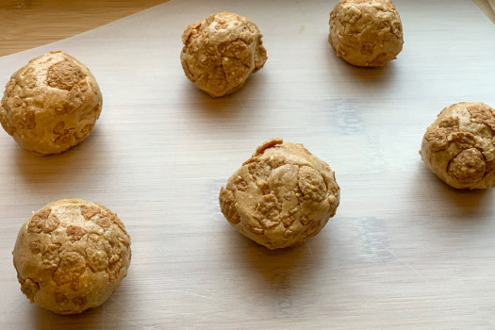

Directions
- Wash your hands and clean your cooking area.
Photo source: myplate.gov
- Mix honey and peanut butter.
- Gradually add dry milk and mix well.
- Chill for easier handling.
- Lightly grease hands with non-stick spray or a little oil and then form mix into small balls.
- Roll in crushed cereal.
- Chill on a baking sheet until firm.
- Refrigerate leftovers within 2 hours.

Note: Honey should not be given to children less than one year of age.

Nutrients Per Serving: (2 honey milk balls) 41 calories, 2 g total fat, 0 g saturated fat, 1 g protein, 5 g carbohydrates, 0 g dietary fiber, 5 g total sugars, and 25 mg sodium

Total Cost per serving: $$$$

