Spring Gardening

April 14th is National Gardening Day! This day has been established to recognize gardening and horticulture, and to encourage more people to plant their own garden. Planting your own garden not only offers physical activity, it also helps improves healthy eating habits by increasing access to vegetables.
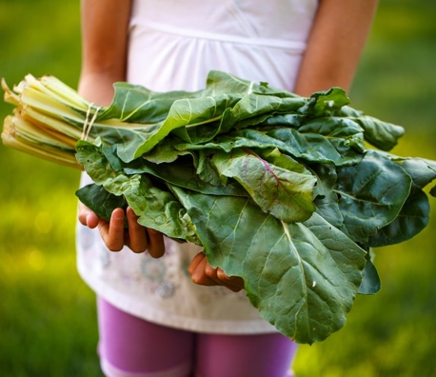
Gardening is fun and although it can be difficult sometimes, its enjoyable watching seeds grow into plants then into vegetables. If I can learn and be successful at gardening, anyone can do it! There have been years that my tomatoes have contracted disease prior to harvesting, worms infested the plants, and I’ve planted seeds too close together resulting in a poor harvest. The reason I do not give up is because there have been successful years that make it worth the effort.
To find answers to my gardening questions, I refer to https://aggie-horticulture.tamu.edu/. This site has been established by Texas A&M Aggie Horticulture and offers vegetable resources with fact sheets on easy gardening, tips for planting a variety of vegetables, and solutions to common problems.
Before you begin gardening, consider what type of garden you want. The three types that Aggie Horticulture recommend are container, raised bed, or tilled gardens. Also consider the garden’s location for good sunlight and water access. When I began gardening, I started with containers and a small raised bed for easy access to pull those pesky weeds. Some of my favorite vegetables to grow are tomatoes, cucumbers, summer squash, and zucchini. One year, I planted watermelon along a fence, and they were the sweetest watermelon I had ever eaten.
Aggie Horticulture also provides a planting chart for the state of Texas. Learning about freeze dates and planting after those dates, will help prevent plants from freezing. Greg Grant, a horticulture agent in Smith County, always recommends planting after Easter as it is better to be safe than lose our plants to cold temperatures.
Help us celebrate National Gardening Day by planting a small garden to enjoy time outside, physical activity, and fresh produce for healthy eating.
Written by Tami Putnam,
Regional Project Specialist - Better Living for Texans
Photo source: unsplash.com

Local Events

Recipe of the Month
Source: MyPlate Kitchen
www.myplate.gov
Sloppy Garden Joes
Servings: 12

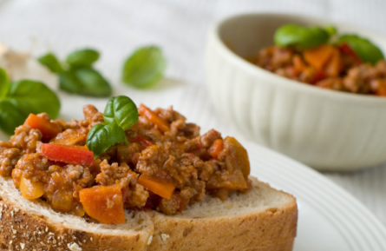
Ingredients
1  1  1  1  1  1  4  ¼  6 | yellow onion, chopped  carrot, chopped or shredded  green pepper, chopped  pound ground turkey or chicken  (8 ounce) can tomato sauce, unsalted  (14.5 ounce) can crushed tomatoes  (2 ounce) cans mushrooms, drained  cup barbecue sauce  whole wheat buns (split in half to make 12)

Directions

- Sauté onions, carrots, green pepper and ground turkey or chicken in a pan over medium-heat for 5 minutes.
- Add tomato sauce, crushed tomatoes, mushrooms, barbecue sauce, and seasonings and bring to boil.
- Reduce heat and simmer for 10 minutes, stirring occasionally.
- Uncover and cook for an additional 3 minutes or until thick.
- Serve open-faced on toasted or plain whole-wheat buns.
- Refrigerate leftovers within 2 hours.

Nutrients Per Serving: (1 sandwich) 160 calories, 6 g total fat, 1 g saturated fat, 0 g trans fat, 28 mg cholesterol, 317 mg sodium, 19 g total carbohydrates, 4 g dietary fiber, 7 g total sugars, 4 g added sugars, and 10 g protein

Total Cost per serving: $$$$

