Personalize Your Plate

Every March the Academy of Nutrition and Dietetics celebrates National Nutrition Month®. This year their slogan is Personalize Your Plate. The idea behind the slogan is that everyone has different needs when it comes to nutrition and everyone has different foods they enjoy eating. There is no one-size-fits-all way to eat!
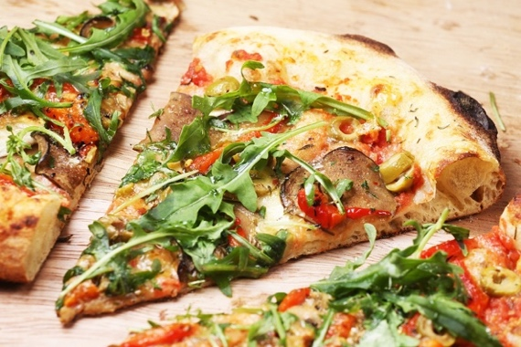
The current Dietary Guidelines for Americans encourages people to customize meals to fit their personal preferences, cultural traditions, and budget.
Meet your nutrient needs by following MyPlate - include all five food groups in your personalized eating pattern.
Picture source: pixabay.com
Personal Preferences
A healthy dietary pattern should start by including nutritious foods that you enjoy! Eating foods that you do not enjoy just because they are healthy, often leads to food waste. Taste preferences change throughout life so keep trying new foods along with new ways to prepare them. Also, provide children with a variety of nutritious meals and snacks to help them develop an eagerness to eat and enjoy a variety of foods.
Incorporate Cultural Traditions
Your cultural background can make a significant impact on the foods you eat. The five food groups included in MyPlate are very broad, making it easy to include foods from all cultures into a healthy dietary pattern. Spices and herbs are a good way to add flavor to meals while also lowering sodium, added sugar, and saturated fat content.
Consider Budget
A common myth is that eating healthy is expensive. A nutritious meal plan can be affordable on a small budget. A few tips to eating healthy on a small budget include meal planning, choosing fruits/vegetables that are in season, incorporating fresh, frozen, canned and dried produce options, and using sale ads and coupons. Better Living for Texans provides many resources on how to eat on a budget. Get in touch with your local AgriLife Extension office to see if there is a Better Living for Texans program in your area!
During National Nutrition Month®, make a goal to incorporate nutritious foods that fit your preferences, culture, and budget into your meal plan.
Adapted from: https://www.dietaryguidelines.gov/sites/default/files/
2020-12/Dietary_Guidelines_for_Americans_2020-2025.pdf

Local Events

Recipe of the Month
Source: MyPlate Kitchen
www.myplate.gov
Simple Stuffed Peppers
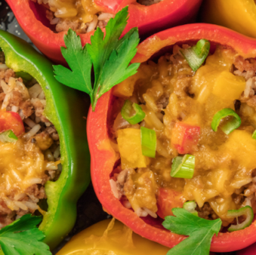
Servings: 4

Ingredients
1  1  4  1  1  1 | cup brown rice, uncooked  can (15 ounce) black beans, unsalted  bell peppers  cup cheddar cheese, shredded, low-fat  tomato, sliced  cup salsa  salt, to taste, optional

Directions

- Preheat the oven to 400°F.
- Cook brown rice according to package directions.
- Wash the peppers under running water. Cut the tops off the peppers and spoon out the seeds.
- Drain and rinse the black beans.
- Combine the beans, rice, salsa and salt (optional).
- Spoon about 3 Tablespoons of the mixture into the bottom of each pepper.
- Place a slice of tomato on top of the mixture and sprinkle with 2 tablespoons of cheese.
- Repeat steps 6 and 7 to fill the pepper completely but do not top with cheese.
- Bake peppers for 30 minutes, top each with 2 Tablespoons of cheese and continue baking for 15 minutes more.

Nutrients Per Serving: 357 calories, 4 g total fat, 2 g saturated fat, 0 g trans fat, 6 mg cholesterol, 599 mg sodium, 63 g total carbohydrates, 13 g dietary fiber, 6 g total sugars, 0 g added sugars, and 19 g protein

Total Cost per serving: $$$$

