Cooking for Two

Cooking a meal for a loved one can be a fun way to celebrate a holiday – however, cooking for just two people on a daily basis can be tricky.
Cooking a whole meal for two can feel like a lot of work with small reward. Eating out may seem like the easier choice, however, cooking meals at home is often healthier and more budget friendly.
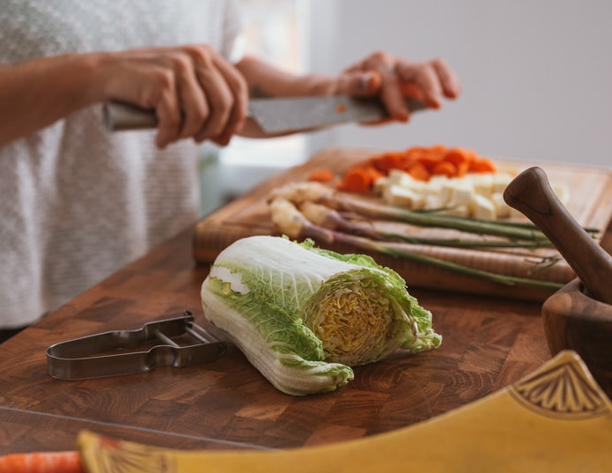
Here are some tips to make cooking for two (or one) easier.
Plan Ahead
Creating a menu for the week can help you avoid relying on less nutritious convenience food or take-out.
When planning meals, think creatively about how to use foods that spoil quickly. For produce, you could plan on adding extra veggies to a sandwich or add fruit to your morning cereal. For meat, you can prepare several servings at one time and then use it in different meals throughout the week. For instance, on Saturday you could cook the chicken then use it for three different meals, like a salad, soup, and rice dish.
Reduce Servings
If your favorite recipes make a lot of servings, you can half the recipe by dividing the ingredients by two, thereby making half the amount of servings. For instance, if the recipe calls for four chicken breasts, only use two.
Adapted from: https://edis.ifas.ufl.edu/pdffiles/FS/FS22400.pdf
Picture source: unsplash.com
Use the Freezer
For recipes that make a lot of servings, freeze half for later. You can reheat the frozen portion on a busy night for a quick, easy meal.
You can also use the freezer to extend the shelf-life of several foods/ingredients.
      - Meat only stays fresh for a few days in the fridge. To help extend the shelf-life, split it into individual portion sizes and store it in air-tight containers in the freezer.
      - Purchasing frozen fruit and vegetables are a great option if you find that fresh fruits and vegetables often spoil before you can eat them. You can also freeze most fresh fruits and vegetables in air-tight containers.
      - The freezer can be used to store grains as well! If it takes you a while to finish a loaf of bread, put it in the freezer to prevent it from becoming stale or moldy. To cut down on cooking time, cook a batch of rice, then freeze it in individual air-tight containers. When you need a single serving of rice, simply reheat it in the microwave.
Meal planning will get easier as you learn and collect recipes that work well for serving 1-2 people or that make good leftovers. Appreciate your hard work by taking time to relax and enjoy the meal you’ve created!

Local Events

Recipe of the Month
Source: MyPlate Kitchen
www.myplate.gov
Pasta Primavera
Servings: 3

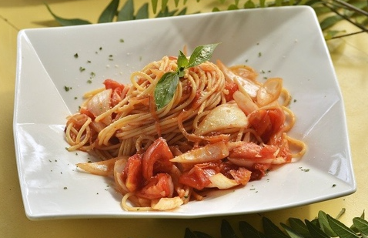
Ingredients
1  1  2  1  1  ¼  ¹/₈  3 | cup noodles, uncooked  Tablespoon, vegetable oil  cups mixed vegetables, chopped  cup tomatoes, chopped  Tablespoon butter  teaspoon garlic powder  teaspoon black pepper  Tablespoons parmesan cheese, grated

Directions

- Cook noodles according to package directions.
- While noodles are cooking, heat oil in a skillet.
- Add vegetables to skillet and sauté until tender; stir constantly.
- Add tomato and sauté for 2 more minutes.
- Add cooked noodles and butter to vegetables and toss.
- Add garlic powder and pepper; sprinkle with Parmesan cheese.

Nutrients Per Serving: 336 calories, 11 g total fat, 2 g saturated fat, 11 g protein, 48 g carbohydrates, 8 g dietary fiber, 4 g total sugars, 0 g added sugar, and 147 mg sodium

Total Cost per serving: $$$$
Photo Source: pixabay.com

