A Fruity Holiday Season

This time of year you can easily find candy canes, hot cocoa, gingerbread cookies, and other holiday treats. Another sweet treat, packed with vitamin C and potassium, that you can easily find during the winter is oranges! In fact, during the winter months all citrus fruits are in season, meaning that they are at peak flavor and often on sale.
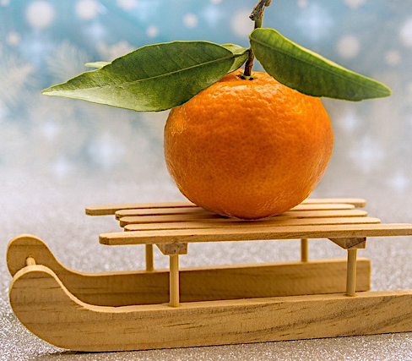
Did you know that during the 1930’s Great Depression oranges were often given as a gift for the holidays? In current times, you might think that an orange is a boring gift but during the Great Depression oranges were a luxury! In the 1930s oranges were hard to find unless you lived near an orange grove. When you could get your hands on them, they were expensive.
These days, oranges are affordable and easy to find, however, some people still carry on the tradition of gifting oranges during the holidays.
Oranges grow well in Texas. The climate in the south part of Texas, specifically the Lower Rio Grande Valley, is perfect for growing grapefruit, oranges, lemons, and other citrus fruits.
The official Texas state fruit is actually the red grapefruit. Grapefruits make up 80% of all the citrus grown in Texas. Next time you buy grapefruit, look at the sticker to see if it was grown in Texas. If you like the idea of gifting oranges, you can put a Texas-spin on this tradition and give family/friends a grapefruit!
Oranges and grapefruit have a fun connection to the holidays and Texas but they are also nutrient packed fruits. These fruits are good sources of:
- Vitamin C
- Vitamin A
- B-Vitamins
- Potassium
These nutrients play important roles in our bodies. For instance, vitamin C helps with wound healing and potassium helps regulate blood pressure.
It is easy to include citrus into our meals and snacks. Mandarin oranges and tangerines are an easy snack or addition to a lunch box. Peeled oranges and grapefruits are tasty in a fruit salad. You could even try squeezing oranges and grapefruit to make your own juice.
This holiday season enjoy some citrus!
Adapted from:: https://www.smithsonianmag.com/arts-culture/why-we-should-bring-back-tradition-christmas-orange-180971101/ and https://pathtotheplate.tamu.edu/?s=grapefruit
Photo Source: pixabay.com

Local Events

Recipe of the Month
Source: Eat.Move.Save. Illinois Extension
Orange Pork Chops
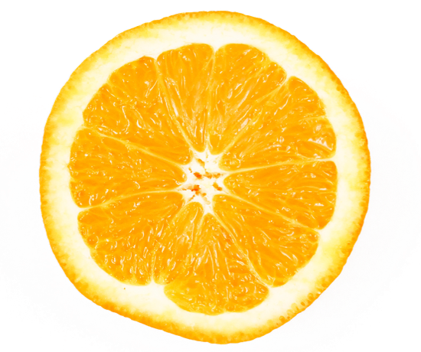
Servings: 4

Ingredients

4  111  2  1  ¼ ¼  ¼ | pork chops  tablespoon cooking oil  raw sweet potatoes or 2 ½ cups canned sweet potato  orange, peeled and sliced  teaspoon cinnamon  teaspoon salt  teaspoon black pepper

Directions
- Preheat oven to 350 degrees F.
- Wash hands with soap and water.
- In a medium skillet, brown both sides of pork chop in vegetable oil.
- Peel sweet potato. Cut into 1/2-inch slices.
- Place browned pork chops in a baking dish and top with sweet potato and orange slices; sprinkle with seasonings. If using canned sweet potatoes, add them half-way through baking pork chops.
- Cover and bake for 1 hour or until meat is tender and thoroughly cooked. Internal temperature of pork chops should reach 145ºF.

Nutrients Per Serving: 240 calories, 9 g total fat, 2 g saturated fat, 21 g protein, 18 g carbohydrates, 3 g dietary fiber, 6 g total sugars, 0 g added sugar, and 119 mg sodium

Total Cost per serving: $$$$
Photo Source: pixabay.com

