A Simple, Stress-Free Thanksgiving

If you love food and spending time with family/friends, you probably love Thanksgiving! Thanksgiving is a wonderful holiday but sometimes it can be stressful, especially if you are in charge of planning and cooking the meal. Since the year 2020 has been unpredictable, and often stressful, consider making Thanksgiving dinner a bit simpler this year.
The Menu
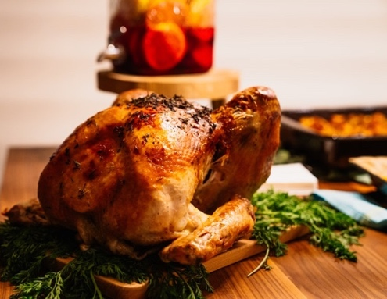
A traditional Thanksgiving dinner includes turkey plus several sides – mashed potatoes, stuffing, green beans, yams, dinner rolls, and the list goes on! It is easy to find yourself making 5+ recipes for Thanksgiving. Not only is this a lot of work, but it can also become expensive.
To make things simpler, consider reducing the menu to:
- Turkey (or a different meat/protein)
- 2-3 sides
- 1 dessert
Talk with your family about what dishes they would like, so no one misses out on their favorite Thanksgiving food. Also ask your family to help you prepare the meal.
If you are having guests over, consider asking them to bring a side dish as well.

Plan Ahead
Whether you keep the menu simple or go all out, planning ahead can make a big difference!
Instead of cooking everything on Thanksgiving Day, think about what recipes you can make/prepare ahead of time. For instance, you could prepare a green bean casserole the day before, so all you have to do on Thanksgiving is put it in the oven. If you have recipes that need vegetables chopped, chop the vegetables 1-2 days beforehand and then refrigerate until they are needed.
You may find that creating a schedule of when food will be prepped and cooked will help reduce stress.
Food Safety
Avoid the stress of catching a foodborne illness by following food safety guidelines. Food safety is simple! Just remember clean, separate, cook, and chill.
Clean hands and surfaces before handling food. Separate fresh produce and cooked foods from raw meats. Cook foods to the proper temperature. Chill foods by quickly storing them in the refrigerator. Food left at room temperature for more than 2 hours should be thrown out.
Have a happy and safe Thanksgiving!
Adapted from:: https://www.fda.gov/consumers/consumer-updates/food-safety-tips-healthy-holidays Photo Source: unsplash.com

Local Events

Recipe of the Month
Source: MyPlate Kitchen
Grandma’s Stuffing
Servings: 8

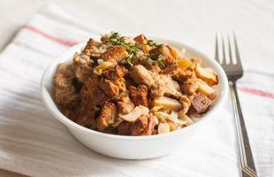
Ingredients
10  ¹/₃11  ½  ½  1  ¼  ¼  1½  1  2 | cups whole wheat bread cubes  cup water  cup onion, chopped  cup celery, chopped  teaspoon dried parsley  teaspoon salt  teaspoon pepper  cups milk  egg, lightly beaten  apples, cored and chopped (optional)  raisins (optional)

Photo Source: MyPlate Kitchen

Directions
- Wash your hands and clean your preparation area.
- Preheat oven to 350 degrees.
- Put bread cubes in a large bowl. Set aside.
- Put water in medium saucepan. Add onion, celery, parsley, salt and pepper. Cook for 5 minutes. Do not drain. Pour over bread cubes.
- Stir in milk and egg. Gently stir in apples, and raisins, if desired.
- Spoon into a greased 2-quart baking dish. Bake at 350 degrees for 1 hour.

Nutrients Per Serving: (1/8 of recipe) 140 calories, 2 g total fat, 1 g saturated fat, 8 g protein, 22 g carbohydrates, 3 g dietary fiber, 5 g total sugars, 2 g added sugar, and 306 mg sodium

Total Cost per serving: $$$$

