Spice Up Your Cooking!

This time of year you can find a “pumpkin spice” version of everything – candy, cereal, coffee, and more! Pumpkin spice foods and beverages are typically flavored with a combination of cinnamon, nutmeg, ginger, and cloves. This blend of flavors makes these foods quite popular!
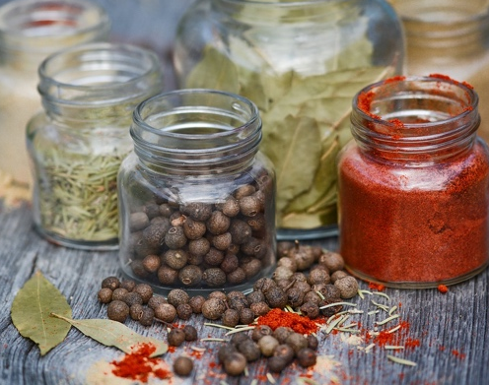
Flavor is one of the top reasons why we choose to eat the foods we eat. The Dietary Guidelines for Americans recommends limiting salt/sodium intake, however, salt is a common source of flavor in the food we eat.
By familiarizing yourself with a few herbs and spices, you can enhance the flavor while lowering the sodium content in foods you prepare.
Spice and Herb Tips
Storing dried herbs and spices in airtight containers on a dry, dark shelf can help preserve its flavor for a few years.
Spices and herbs have very minimal nutritional value, meaning they won’t increase sugar, fat, salt, or calories in a food. They are simply used to enhance the flavor of a dish.
Herbs and spices vary in strength of flavor. If you are experimenting with flavors, it’s a good idea to start with just a pinch and then taste test. You can always add more but once it’s added, there’s no going back.
The following information may help you know where to start when it comes to flavoring dishes with herbs and spices:
Strong flavor: bay leaf, cardamom, curry, ginger, pepper, mustard, rosemary, sage
Medium flavor: basil, cumin, dill, fennel, garlic, marjoram, mint, oregano, thyme, turmeric
Sweet flavor: cinnamon, cloves, allspice, ginger, cardamom, mint, fennel
Savory flavor: oregano, garlic powder, curry powder, dill, onion powder
Peppery flavor: mustard, black pepper, paprika, cayenne pepper, chili powder
Since spices and herbs can be expensive - start with a few basics like pepper, basil, oregano, and cinnamon. For spices that you use a lot, it is cheaper per ounce to purchase the spices in bulk.
Next time you cook, loosen your grip on the salt shaker and pick up some herbs and spices!
Adapted from:: https://www.udel.edu/academics/colleges/canr/cooperative-extension/fact-sheets/using-herbs-and-spices/ Photo Source: unsplash.com

Local Events

Recipe of the Month
Source: foodhero.org

Pumpkin Fruit Dip
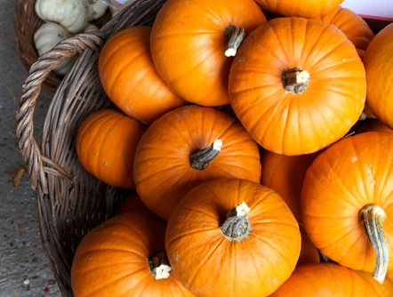
Servings: 26
Makes: 3 cups

Ingredients
1 | can (15 ounce) pumpkin
111 | cup plain yogurt or low-fat cream cheese
¾ | cup sugar
1 ½ | teaspoons cinnamon
½ | teaspoon nutmeg

Photo Source: pixabay.com

Directions
- Wash your hands and clean your preparation area.
- In a large bowl, combine pumpkin, yogurt or cream cheese, cinnamon and nutmeg. Add sugar a little at a time to reach desired sweetness. Stir until smooth.
- Serve with sliced fruit.
- Refrigerate leftovers within 2 hours.

Nutrients Per Serving: (2 tablespoons) 40 calories, 0.5 g total fat, 0 g saturated fat, 1 g protein, 8 g carbohydrates, 1 g dietary fiber, 7 g total sugars, and 25 mg sodium

Total Cost per serving: $$$$

