Smart Snacking for Kids

Having a snack can be a great way to satisfy hunger when it isn’t meal time. Snacks can help kids stay focused when they’re at school or when they work on homework. Snacking too much, too often, or frequently snacking on low-nutrient foods can disrupt kid’s appetite.
When Should Kids Snack?
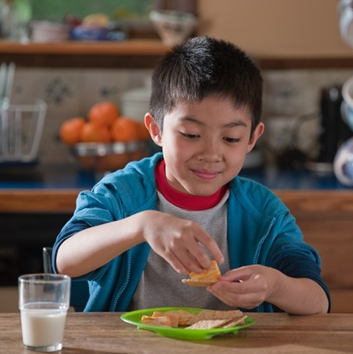
Snacks at the right time can provide kids with the energy and nutrients they need. Nonstop snacking can make it harder for kids to know when they are actually hungry or full.
A good rule of thumb for kids is three meals a day and two snacks. If you feel like your kids are constantly asking for a snack, having a set snack time can help (for example, right after school).
Providing kids with a snack an hour or two before a meal will help them avoid filling up on the snack and maintain a healthy appetite.
Pick an area for kids to eat their snack – for instance, at the table or counter. When kids are distracted by the TV or other electronics it can make it harder for them to realize when they are full. Mindlessly snacking while doing other things can lead to overeating.
Smart Snacking
Here are some tips that can help you and your kids be smart snackers:
  - Smaller kids need smaller portions
- A snack with protein and fiber will help kids feel full for longer (examples -whole wheat crackers with cheese, trail mix, yogurt and fruit)
- Use frozen or canned fruits for a budget-friendly snack option (choose fruit canned in water or 100% juice, not syrup)
- Keep a bowl of fruit in plain sight and veggies that are ready for snacking at kids-eye level in the fridge.
What smart snacking tips will you try?
Adapted from: https://www.eatright.org/food/nutrition/dietary-guidelines-and-myplate/when-should-my-kids-snack
Photo Source: snaped.fns.usda.gov

Local Events

Recipe of the Month
Source: MyPlate Kitchen

Strawberry Yogurt Pops
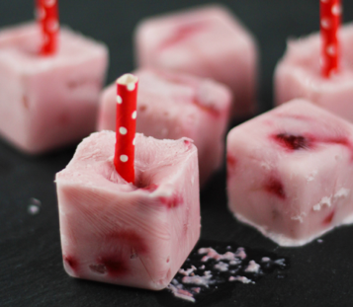
Servings: 4

Ingredients
1 | cup low-fat strawberry yogurt
6 | large strawberries
1 | ice cube tray or small paper cups
 | Popsicle sticks or cut plastic straws

Photo Source: choosemyplate.gov/myplatekitchen

Directions
- Wash your hands and clean your preparation area.
- Wash the strawberries, then cut into small pieces. Mix fruit and yogurt.
- Divide mixture into 4 small paper cups (or 8 ice cubes). Place a popsicle stick or straw into each cup/cube.
- Freeze.
- Enjoy!
Fun Tip: You can try this recipe with different fruits like, pineapple or kiwi!

Nutrients Per Serving: (1 fruit pop cup) 71 calories, 1 g total fat, 0 g saturated fat, 3 g protein, 14 g carbohydrates, 1 g dietary fiber, 13 g total sugars, 7 g added sugars, and 36 mg sodium

Total Cost per serving: $$$$

