It’s Hot! Stay Hydrated!

It is summer time in Texas which means, it is hot outside! With these hot temperatures it is important to stay hydrated. The main way to stay hydrated is by drinking water, however, eating fruits and vegetables with a high-water content, like cucumbers or watermelon, also helps!
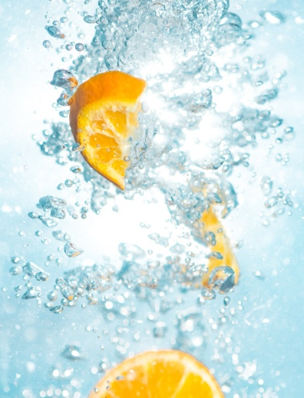
Stay Hydrated
Staying hydrated is important for many reasons. Good hydration helps you maintain a normal temperature, cushions joints, protects the spinal cord, and removes waste through urination, bowel movements, and perspiration.
When you are dehydrated you can experience dizziness, headaches, and/or digestive issues.
If dehydration worsens it can affect your mood, memory, and ability to focus.
How much?
Determining how much fluid you need daily is a little more complicated than you might think. Age, gender, activity level, and general health all play a factor in how much fluid someone should drink.
A general fluid recommendation for adults is 9 cups/day for women and 13 cups/day for men.
Source: https://www.eatright.org/food/nutrition/healthy-eating/how-much-water-do-you-need and https://www.cdc.gov/healthywater/drinking/nutrition/index.html
Photo source: unsplash.com
If you are out in the hot Texas weather, your fluid needs will increase to make up for the fluid you lose through sweat. Increased physical activity and illness, especially diarrhea and vomiting, will also increase your fluid needs.
Here are some tips to increase your fluid intake:
- Carry a water bottle with you while running errands
- Listen to your body, drink water as soon as you feel thirsty
- Drink water with every meal, and between meals
- Place a reminder to drink water on your fridge or phone
Not a fan of water?
Water is recommended over other drinks because it is zero calories and has no added sugar. There are people, however, who simply do not like the taste of water.
To enhance the flavor of water without adding sugar, you can add some sliced fruit or vegetables. Cucumbers, berries, and citrus fruits are common foods that add flavor to plain water without adding many calories.

Local Events

Recipe of the Month
Source: Better Living for Texans

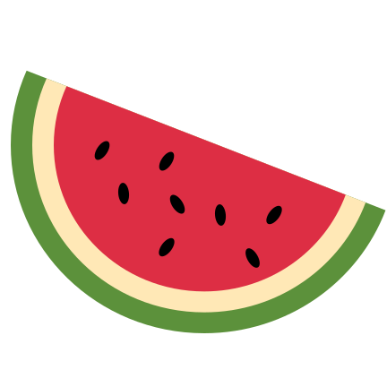
Red, White, & Blue Salad
Servings: 6

Ingredients
3 | cups watermelon, cut into 1-inch cubes, seeded
1 | cup blueberries
2 | medium bananas, sliced
1 | cup fat free whipped topping
 | Juice of 1 lime

Photo source: canva.com

Directions
- Wash your hands and clean your cooking area.
- Wash all fruit.
- Place cut watermelon and blueberries in medium bowl.
- Slice bananas and place in a small bowl. Squeeze lime juice over bananas and mix, covering all bananas.
- Add bananas and whipped topping to the watermelon and blueberries, mix well.
- Chill until ready to serve.

Nutrients Per Serving: (1 cup) 90 calories, 0 g total fat, 0 g saturated fat, 1 g protein, 23 g carbohydrates, 2 g dietary fiber, 13 g total sugars, and 10 mg sodium

Total Cost per serving: $$$$

