Perks of Gardening

During the COVID-19 pandemic you may have felt a little bit of fear, anxiety, and uncertainty. You might have been concerned by the food shortage at stores. Even though shortages appear temporary, this uncertainty about food shines a light on the benefits of having a vegetable garden at home.
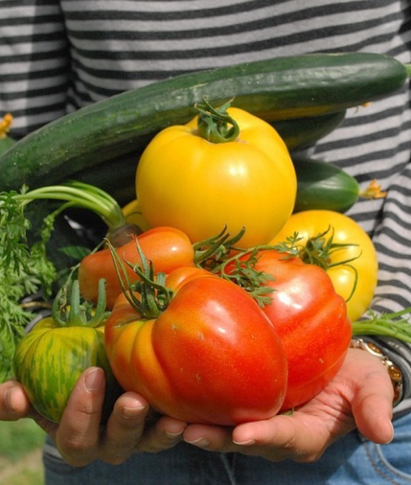
Having a vegetable garden at home gives us direct access to fresh fruits and vegetables. With a garden we tend to eat more fruits and vegetables, and this means better health, including support for a good immune system.
Many areas in Texas are considered “food deserts”, these are places where the availability of affordable, healthy, fresh food is limited. Gardening at home or participating in a community garden helps us save money by allowing us to enjoy harvesting our own vegetables and save our grocery budget for other items.
According to the article “Gardening as Exercise” by Texas A&M University Aggie Horticulture Department, having a vegetable garden is not only a good source of vitamin and minerals, but a good way to get more exercise. In this article, experts say even less strenuous exercises, like gardening, can help you burn off 300 calories. Cleaning a garden – weeding, trimming, raking – can also help tone your muscles. The article recommends using manual equipment instead of power equipment to boost your garden workout.
Article by Heidi Lopez, Starr County Extension Agent – Better Living for Texans
Photo source: pixabay.com
Being outdoors helps people relax and feel happy while isolated or self-quarantined. Pulling weeds can help you release stress and smelling fresh herbs can lift spirits! A successful garden also gives you a great sense of achievement.
Gardening can be especially fun with friends and family. Children get excited about growing food. Gardens support their capacity for wonder, admiration for growing plants, and increase their likelihood to try different vegetables.
Gardening at home or at a community garden can help you save money at the grocery store, improve physical fitness, uplift your spirit, and provide quality time with friends and family. Growing your own food can lead to nutritious meals and improved health.

Local Events

Recipe of the Month
Source: Eat Smart, Be Fit Maryland

Veggie Quesadilla
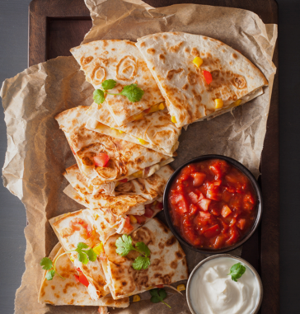
Servings: 4

Ingredients
1 | zucchini | 4 | whole wheat tortillas
½ | broccoli head | 1 | cup low-fat cheddar cheese, shredded
1 | bell pepper, seeded | 1 | cup salsa
1 | small onion, peeled |  | cooking oil spray
1 | carrot, shredded

Directions
Photo source: canva.com
- Wash your hands and clean your cooking area.
- Wash and chop the vegetables.
- Spray pan with cooking oil spray.
- Cook vegetables on medium heat for 4-5 minutes, stirring frequently. Remove from pan.
- Spray pan with cooking spray. Place tortilla in the pan. Sprinkle with half the vegetables and half of the cheese.
- Place the other tortilla on top. Cook on medium heat for 4-6 minutes or until the cheese starts to melt and the bottom tortilla starts to brown.
- Flip quesadilla. Cook for 4 minutes or until tortilla browns.
- Repeat steps 3-5 for each quesadilla.
- Cut each quesadilla in half. Serve with salsa

Nutrients Per Serving: (1/2 quesadilla) 200 calories, 4 g total fat, 1.5 g saturated fat, 11 g protein, 33 g carbohydrates, 7 g dietary fiber, 7 g total sugars, and 710 mg sodium

Total Cost per serving: $$$$

