The Run Down on Physical Activity

Many people struggle finding time or motivation to exercise. Some people don’t know where to start or feel like they lack resources to exercise.
Sometimes exercising feels like a drag, so why do it? In addition to building muscle and strength, other reasons to exercise include improved:
- Stress
- Sleep
- Mood
- Focus
Long-term effects of being physically active include lower risk for some diseases, improved blood pressure, and healthy weight maintenance
Let’s review some of the basics of physically activity.
How Much Exercise Do Adults Need?
Experts recommend that adults engage in 150 minutes a week of moderate-intensity aerobic exercise. In addition, it is recommended to do muscle-strengthening activities at least 2 days a week.
- Moderate-intensity aerobic exercise: movement that makes the heart beat faster (examples: brisk walking, yard work).
- Muscle-strengthening: movement that makes muscles work harder than normal (examples: push-ups, weight lifting).
Children ages 6-17, should aim for at least 60 minutes of moderate to vigorous physical activity daily.
Finding Motivation
Most people would probably agree that they prefer to spend their time doing something they enjoy. If someone doesn’t like running, lifting weights, or lunges, they probably won’t do those things very often.
Find physical activity that is enjoyable! Whatever involves moving counts – gardening, dance party in the living room, walking with family or friends, etc.
Keep It Simple!
Fancy equipment or a gym membership is not needed to be active. Be creative and think of simple ways to be active without spending a dime.
When setting a goal, start simple and build! Possibly start by making a goal to take a walk once a week. After a few weeks of meeting that goal, bump it up to two walks a week.
Setting goals that are too high can cause discouragement. Start with what you know you can do!
Information from: https://www.cdc.gov/physicalactivity/basics/
adults/index.htm. Photo Source: snaped.fns.usda.gov

Local Events

Recipe of the Month
Source: Better Living For Texans
Start your St. Patrick’s Day off extra green with this tasty smoothie!

Green Monster Smoothie
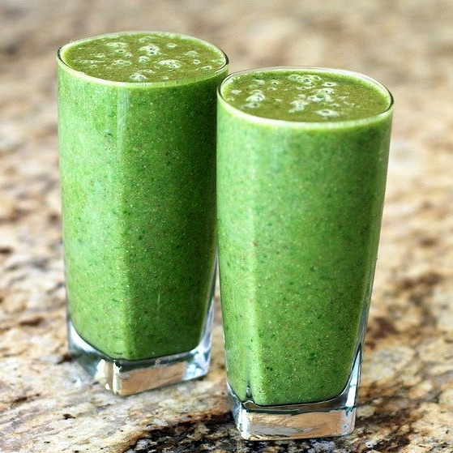
Servings: 4 smoothies

Ingredients
½ | cup frozen spinach
¾ | cup low-fat vanilla yogurt
1 | medium banana
½ | cup pineapple chunks canned in 100% juice

Photo Source: pixabay.com

Directions
- Wash your hands and clean your cooking area.
- Add all ingredients to blender and process until smooth.
- Serve immediately.
- Cover and refrigerate leftovers.

Nutrients Per Serving: (1 cup) 70 calories, 0 g total fat, 0 g saturated fat, 3 g protein, 16 g carbohydrates, 2 g dietary fiber, 12 g total sugars, and 90 mg sodium
Total Cost per serving: $$$$

