Kids in the Kitchen

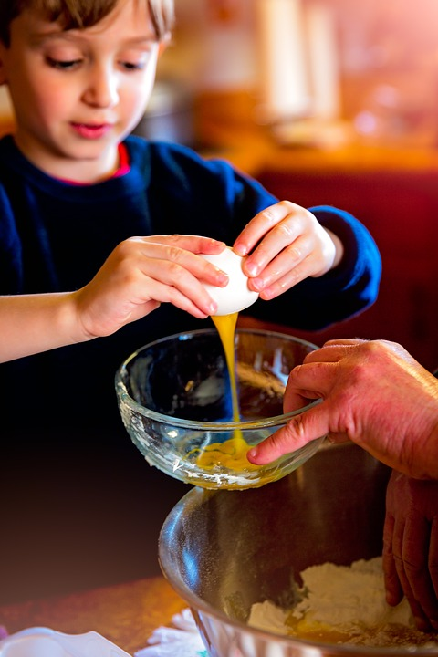
In addition to gathering family and friends around the table this Thanksgiving, try gathering together in the kitchen! More specifically, invite children to help out with the meal preparation. Thanksgiving is a great time for children to gain confidence in their cooking skills. Imagine how a child will feel when everyone loves the salad they mixed or potatoes they mashed!
Helping in the kitchen can also help children learn food safety and develop fine motor skills. Plus, who ever said no to a little extra help preparing Thanksgiving dinner?

The Basics
Depending on the age of the children, it may be helpful to show them the purpose and importance of different kitchen tools. For instance, explain that the measuring cups help make sure there is enough of each ingredient.
Teach children different skills used when cooking, like how to crack an egg or peel a potato.
Meal preparation can start days before Thanksgiving. Teach children which foods and recipes can be made beforehand so that Thanksgiving Day is a little less busy.
Article Source: https://www.eatright.org/food/resources/eatright-infographics/kid-friendly-kitchen-tasks-infographic
Photo Source: pixabay.com

Age-Appropriate Tasks
The ability to safely perform cooking tasks varies by age – can you imagine a toddler chopping onions? Yikes! Here are some general guidelines for age-appropriate tasks:
- 3-5 years old: rinse produce, mix simple ingredients, cut soft ingredients with a plastic knife
- 6-7 years old: crack eggs, use a vegetable peeler, shuck corn
- 8-9 years old: use a can opener, measure ingredients, check food temperature using a thermometer
- 10+ years old: slice/chop produce, bake, boil, microwave and simmer foods, follow a simple recipe

Food Safety
Following good food safety practices is important for all ages. When having kids help out in the kitchen make sure to teach the following food safety tips:
- Before cooking, clean all surfaces that will touch food.
- Wash hands for 20 seconds in warm, soapy water, before and after touching food.
- Don’t taste food before it is done cooking.
- Always have an adult around when cooking.

Have a happy and food safe Thanksgiving!

Local Events

Recipe of the Month
Source: Better Living for Texans

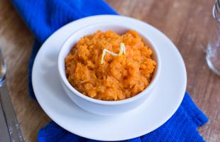
Mashed Sweet Potatoes
Servings: 8
Serving Size: ½ cup

Ingredients
4 | medium sweet potatoes, peeled
1 | tablespoon butter
¼ | cup fat-free milk
⅓ | cup brown sugar
1 | teaspoon cinnamon

Photo Source: whatscooking.fns.usda.gov

Directions
- Wash your hands and clean your cooking area.
- Fill a large sauce pan with water and bring to a boil.
- Wash and cut sweet potatoes into small cubes.
- Put potatoes in boiling water and cook until potatoes are soft (about 15-25 minutes).
- Remove potatoes and place in a bowl.
- Mash potatoes with potato masher or fork.
- Add butter, milk, brown sugar and cinnamon, and mix well.
- Spoon into a bowl or plate and serve immediately.

Nutrients Per Serving: 100 calories, 1.5 g total fat, 1 g saturated fat, 1 g protein, 22 g carbohydrates, 2 g dietary fiber, 13 g total sugars, and 30 mg sodium
Total Cost per serving: $$$$

