

On the Track to Better Health….

December 2016 BLT Newsletter
Ending the year on a healthy note

Thanksgiving can be a great time to enjoy taking time to reflect on our lives, enjoy family, and dine on delicious foods. While most of us look forward to the upcoming feast, some are concerned about the calories they’ll consume during a typical Thanksgiving meal. The USDA estimates that a traditional Thanksgiving meal consisting of a turkey dinner with candied yams, mashed potatoes, stuffing, cranberry sauce, breads, gravy, and desserts (i.e. a slice of pie in the afternoon and a slice of cake after dinner) will result in the consumption of over 1800 calories.
In case you’re wondering, the daily recommended caloric allowance for a moderately active male between the ages of 26 and 45 is 2,600. For a moderately active female of the same age, the recommend daily caloric intake is 2,000.
Better Living for Texans would like to offer some ways to enjoy your Thanksgiving meal without feeling stuffed when it’s over.
- Take time to look at the entire menu and decide which foods you really want to eat. You don’t have to sample everything to enjoy the meal.
- Eat slowly so your body has more time to signal fullness.
- Don’t starve yourself until the main meal. Eat a small to medium-sized breakfast and lunch during the day and drink lots of water to reduce the chance of overeating at dinner.
- Use a smaller plate to control your portion size.
Still another option for Thanksgiving is to prepare a healthier food item to replace one of the traditional, high-calorie menu options. For instance, replace mashed potatoes with pumpkin soup. This, or another small menu tweak, won’t harm the tradition or change the feel of the Thanksgiving meal, but it will provide an option for those wanting to reduce their calorie intake while still enjoying a great time with family and friends. Happy Thanksgiving!
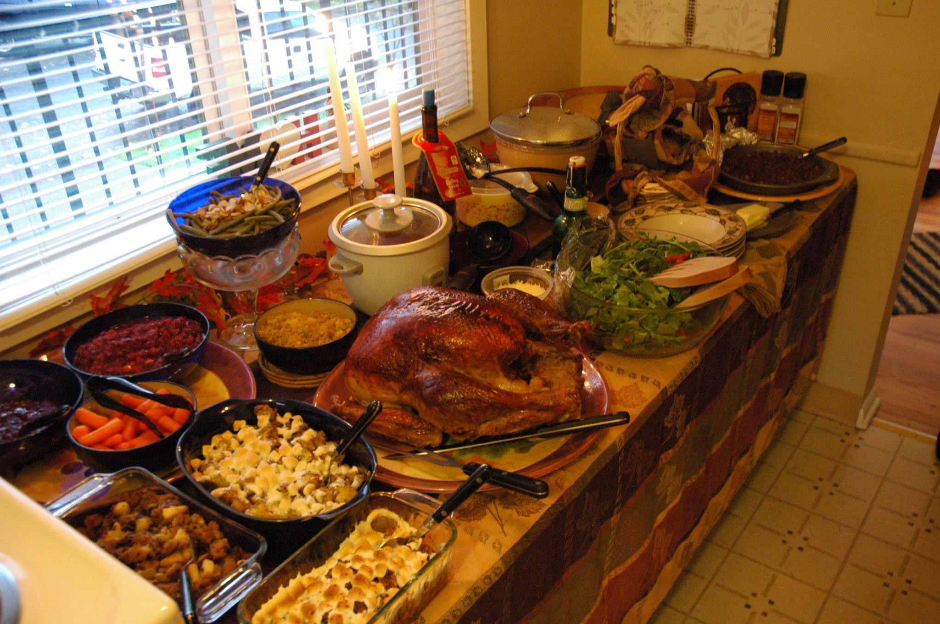
Local Events

Recipes of the month:

Pumpkin Soup

Ingredients
- 3/4 cup water, divided
- 1 small onion, chopped
- 1 can (15 ounces) pumpkin puree
- 2 cups unsalted vegetable broth
- 1/2 teaspoon ground cinnamon
- 1/4 teaspoon ground nutmeg
- 1 cup fat-free milk
- 1/8 teaspoon black pepper
- 1 green onion top, chopped

Directions
In a large saucepan, heat 1/4 cup water over medium heat. Add onion and cook until tender, about 3 minutes. Don't let onion dry out.
Add remaining water, pumpkin, broth, cinnamon and nutmeg. Bring to a boil, reduce heat and simmer for 5 minutes. Stir in the milk and cook until hot. Don't boil.
Ladle soup into warmed bowls and garnish with black pepper and green onion tops. Serve immediately.
Serves 4
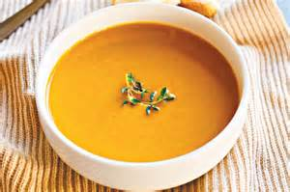

Low-fat turkey gravy

Ingredients
- 4 cups (32 fluid ounces) unsalted turkey stock, divided
- 2 tablespoons fresh sage, remove from stem and finely chop
- 2 tablespoons fresh thyme, remove from stem and finely chop
- 1 cup (8 fluid ounces) skim milk
- 1/4 cup cornstarch

Directions
After roasting the turkey, place the roasting pan on the stove top over medium heat. Add 2 cups of turkey stock to the pan and stir for 5 minutes or until the drippings and browned bits from the bottom of the pan dissolve. Place a strainer over a fat separator cup. Pour pan drippings through strainer. Add enough stock to the drippings to make 4 cups total.
If you don't have a fat separator cup, you can remove fat from drippings by add several ice cubes to the liquid and placing it in the freezer for 10 minutes. Remove hardened fat with spoon and place stock into a saucepan. You should still have about 4 cups of liquid.
Place the saucepan on the stove top over medium heat and bring to a simmer. Add sage and thyme to the simmering stock. Continue to simmer until the stock is reduced by 1/4, or until about 3 cups of stock remain.
Pour milk into a small bowl. Add cornstarch and stir to mix evenly. Slowly pour milk mixture into the simmering stock, stirring slowly. Bring sauce to a boil and continue to stir until stock thickens and has a nice shine, about 3 to 5 minutes.
Pour gravy into warmed gravy boat and serve.

