

On the Track to Better Health….

August 2016 BLT Newsletter
Yogurt Facts

It’s safe to say that most want to eat healthier while still enjoying foods that taste good. Dessert-lovers can find it particularly challenging to find a healthy balance between a craving to satisfy a sweet tooth and the desire to be health conscious. That is where yogurt often comes in.
Yogurt was once a high-fat dairy product with few flavor options. Today, yogurt manufacturers offer yogurts of various flavors and consistencies (such as tubes for squeezing, drinkable versions, lactose-free, fat-free, low-fat, and others). In fact, one particular manufacturer offers over 99 distinct flavors! The public has noticed, and yogurt consumption has steadily increased over the last twenty years with no sign of sales slowing down.
Many assume that any yogurt is a healthy, high-calcium snack, but is it really?
Variety of flavors or health benefits
In meeting consumer demands for more flavor options, some yogurts offer less calcium than other dairy products on the market. A University of Virginia study (2011) revealed that some drinkable yogurts, kid-friendly versions, and dessert-inspired yogurts fall short in calcium content in comparison with an 8oz glass of milk or 1.5 oz. of most cheeses. Flavored yogurts are often high in sugar content. A close look at the nutrition label on an 8 oz. cup of yogurt reveals that sugar content can range from 9-12 grams on the low-end to over 30 grams on the high end. This is also true of many of the kid-friendly yogurt products on the market.
The reality is that yogurt, like most foods available to us, has good and not-so-good options on the market. It is up to the consumer to make an educated purchase. One of best ways to ensure that your yogurt purchase will bring the most health benefits while combining lower sugar content and higher dairy content is to select unflavored yogurt and add natural sweeteners like fresh or frozen fruits.
When choosing a flavored yogurt, check the sugar and dairy content on the nutrition label and look for low-fat or fat-free varieties.
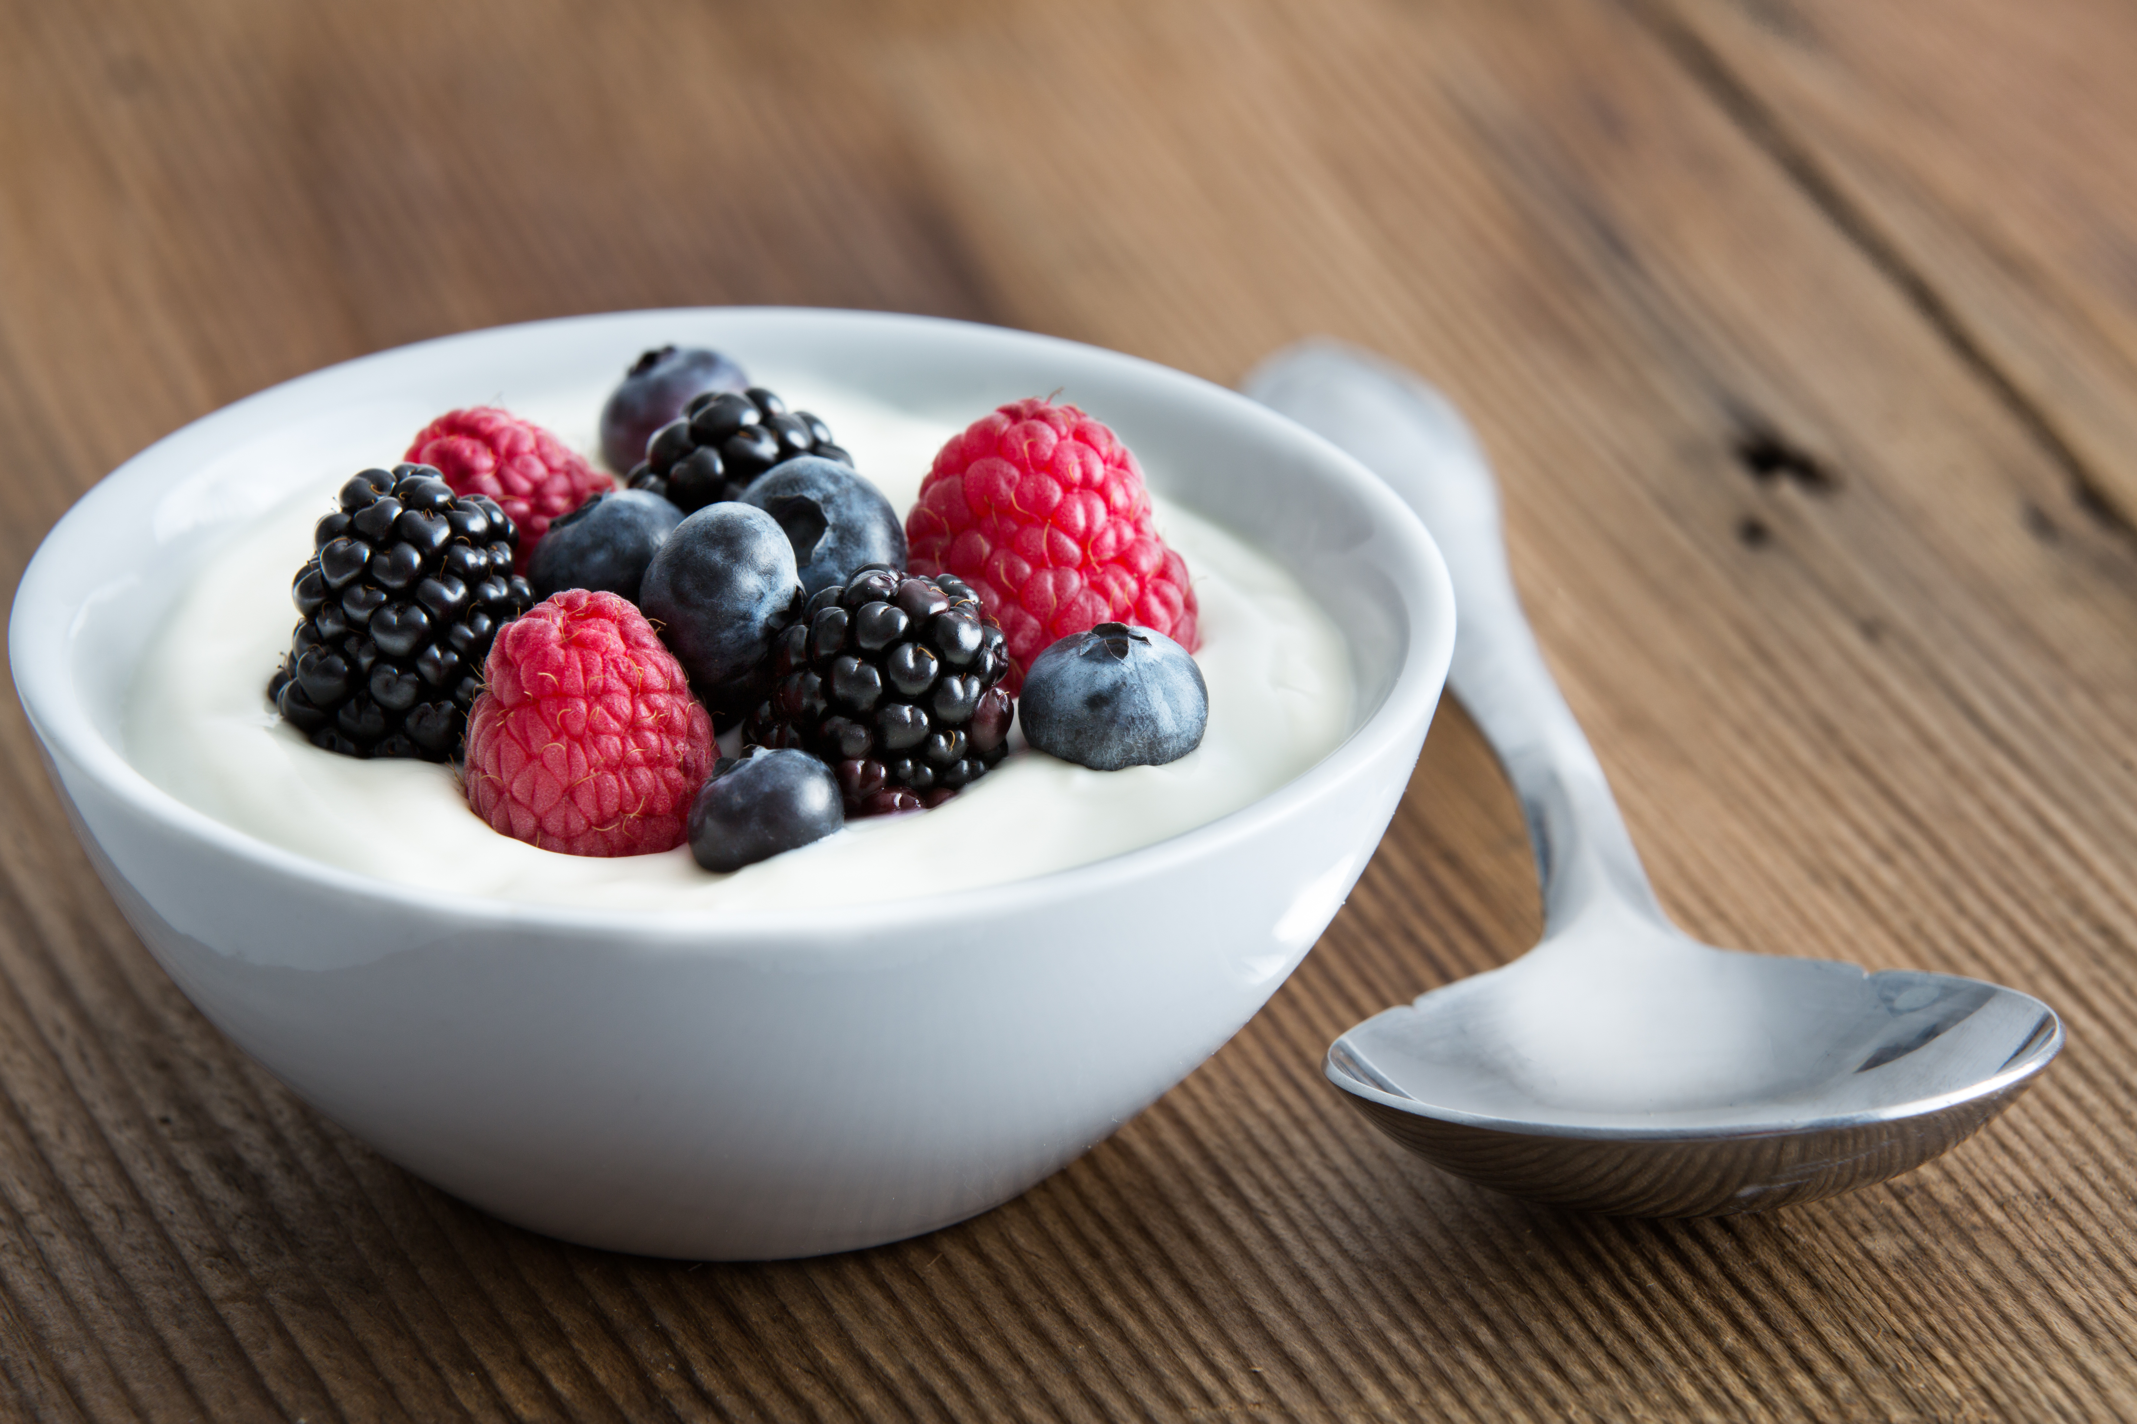
*Source University of Virginia: https://med.virginia.edu/ginutrition/wp-content/uploads/sites/199/2014/06/Parrish_Feb_14.pdf
Local Events

Recipes of the month:
Vegetable Dipping Sauce
Makes: 4 Servings
Total Cost: $0.68
Serving Cost: $0.17

Ingredients
¼ cup yogurt, non-fat plain
¼ cup sour cream, light
2 teaspoons honey
2 teaspoons brown mustard (spicy)

Directions

Mix together all ingredients and serve with vegetables (suggestions: carrot sticks, broccoli, cauliflower, tomatoes, or any of your favorite vegetables).

Fruit and Yogurt Breakfast Shake
Makes: 2 Servings
Total Cost: $1.17
Serving Cost: $0.58

Ingredients
1 banana (medium, very ripe, peeled)
¾ cup pineapple juice
½ cup yogurt, low-fat vanilla
½ cup strawberries (remove stems and rinse)

Directions

Blend banana with pineapple juice and strawberries in a blender.
Blend until smooth
Divide shake between 2 glasses and serve immediately.



