Fighting Obesity

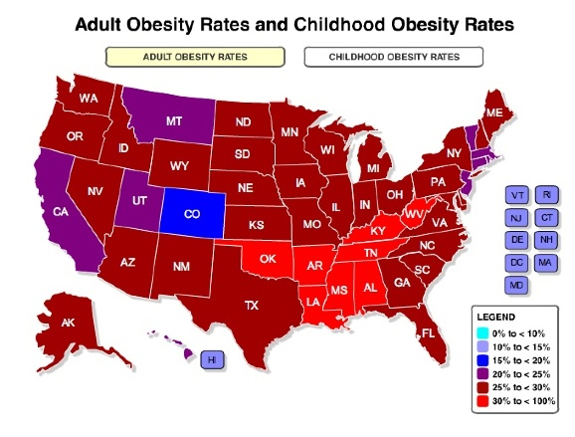
Obesity is a problem issue for both adults and children in Texas (and across America). Obesity can lead to increased risk of health issues like diabetes, high cholesterol, heart disease, respiratory problems, and some cancers. Obesity is characterized by too much body fat due to the body not being able to balance food intake with energy output. Among the most effective ways to prevent obesity is through a combination of healthy eating and plenty of exercise. It’s important not to get caught up in the obsession to lose weight when making healthy changes to your diet and exercise regimen. The most important thing you’re doing is improving your health, of which weight loss might be a result.
Contact Better Living for Texans to learn more about ways to prevent obesity and/or to begin living a healthier lifestyle.
Local Events:

Recipe Central: Chicken and Cranberry Salad
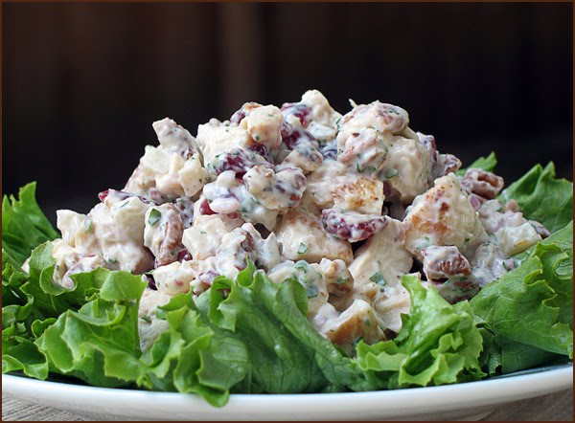

Ingredients
12 ounces chicken, cooked and diced (1 ½ cups)
½ cup vinaigrette dressing
1 cup dried cranberries
2 tablespoons almonds (sliced)
1 head of lettuce (chopped)

Instructions
- Toss chicken, cranberries, and almonds with dressing.
- Serve on a mound of chopped lettuce

Cost:
$7.04 per recipe (serves 4)
$1.76 per serving
If you are interested in enrolling in nutrition education classes offered by Better Living for Texans, contact the Family and Consumer Sciences Agent at your local Texas AgriLife Extension Office: ___________________________________________________________
______________________________________________________

