Gardening as Part of a Healthy Lifestyle

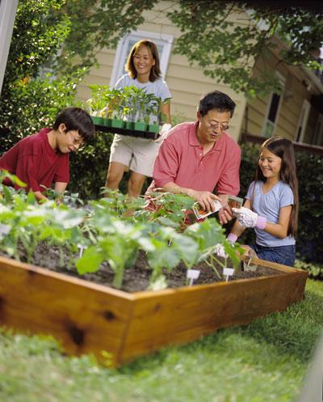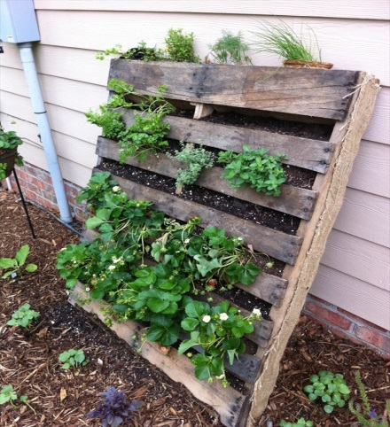
Starting a family garden is a great way to spend time with your children during the summer months. Children are often much more inclined to try a vegetable (or fruit) that they’ve helped plant and watched grow. While planting together, take the time to talk to your children about the benefits of eating more fruits and vegetables. You may be surprised to see the benefits of cultivating nutrition concepts into your children as you cultivate a family garden. If you’d like to learn more about setting up and maintaining a family garden, contact the Better Living for Texans Program or your Texas AgriLife Extension Office’s Family and Consumer Sciences Agent. We’d love to talk to you!
Water
Water intake is necessary, especially as we move into the hot summer months. Water prevents dehydration, in part, by lubricating body tissues and carrying nutrients and oxygen to our cells. Children and the elderly are particularly susceptible to dehydration, but so are younger and middle-aged adults. Many people don’t realize they are dehydrated until it is too late. In fact, by the time a person feels thirsty they have already begun to dehydrate. Don’t wait to hydrate!

Local Events:

Recipe Central: Summer Fruit Salad

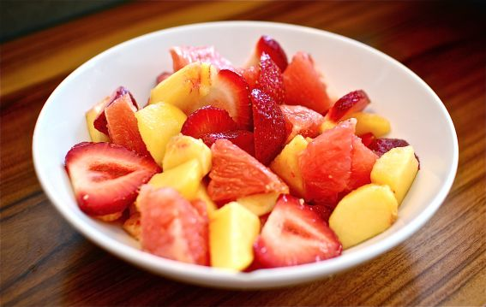

Ingredients
1 cup | strawberries (diced, fresh or frozen)
1 cup | watermelon (cubed)
1 cup | pineapple chunks, fresh or canned packed in natural juice (and do not drain)

Instructions
- Stir fruit together in a medium sized bowl.
- Cover and chill. Serve as soon as possible.

Cost
Per recipe: $1.44
Per serving: $0.36
If you are interested in enrolling in nutrition education classes offered by Better Living for Texans, contact the Family and Consumer Sciences Agent at your local Texas AgriLife Extension Office: ___________________________________________________________
______________________________________________________

