COOKING IN BULK TO SAVE MONEY:
Good idea or risky?

Many families have adopted the practice of cooking a lot on the weekends so that they eliminate the hassle of meal planning during the busier weekdays. The question that often comes up from this practice is how the meals should be stored. For example, if making a large pot of soup, should it be left to cool on the counter prior to refrigerating or should it be refrigerated immediately? The fact is that both practices can be risky.
Letting foods cool at room temperature for more than two hours exposes foods to the “danger zone” of temperatures which ranges between 40 degrees and 140 degrees Fahrenheit. In that environment, bacteria can multiply rapidly. Even when placing large pots in the refrigerator it may take up to eight hours to cool the food below 40 degrees because of the size of the pot and the time it takes for the contents to absorb the cool air. This is much too long for safety concerns.
With the goal of bringing foods to cool as quickly as possible, the best option is to put hot, cooked foods into shallow containers (not more than 2 inches deep) and refrigerate immediately. A potholder placed under the container will prevent heat from cracking interior refrigerator shelves. If cooking foods such as a roast, large ham, or turkey, the meat should be sliced or cut into small portions and refrigerated immediately in a small container.
When storing leftovers in the refrigerator, most experts recommend that they be discarded after three or four days. For longer storage, consider placing cooked foods in the freezer. Label the contents with the date that the food is being frozen. For best quality, use within 3 to 4 months. When using frozen leftovers, it is a good idea to thaw them first by placing them in the refrigerator overnight. Never leave food out at room temperature to thaw. Reheat the leftovers until they are 165 degrees or steaming hot.
Source: http://www.fsis.usda.gov/PDF/Leftovers_and_Food_Safety.pdf

Recipe Central:
Try this dish for a healthy Valentine’s Day meal:
Chicken and Broccoli Bake [Yields 8 servings and costs $0.95 per serving]
Ingredients

1 cup rice, uncooked

1 package broccoli, frozen (10 ounce)

3 cups chicken, cooked

2 tablespoons margarine (or butter)

¼ cup flour

2 cups chicken broth

¼ cup parmesan cheese (optional)

Instructions
1. Cook rice in 2 cups of water.
2. Let broccoli thaw.
3. Chicken should be off the bone (chopped or shredded).
4. Melt butter in large sauce pan.
5. Add flour to melted margarine and stir. This will be lumpy.
6. Slowly add broth to margarine/flour. Stir to remove lumps and thicken.
7. Add cheese and stir.
8. Add rice, broccoli, and chicken. Stir.
9. Put in a casserole pan and bake at 350 degrees F for 30 minutes or until thoroughly heated.
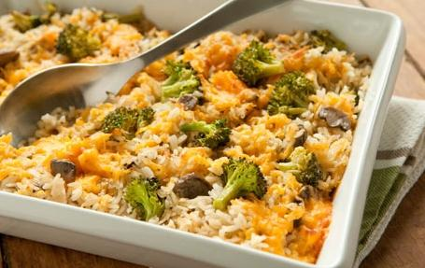
Source: recipefinder.nal.usda.gov

