The Better Living for Texans Program is always excited to bring nutrition education to the people of Texas. Fitness is a popular, year round topic. Many of your friends, family, or perhaps even you pledged to “get fit” and began fitness activities such as walking, bicycling, climbing stairs and other activities. Well, if you or someone you know made that pledge, are you sticking to it? If you’re like most people, you did one of two things: 1) You never quite found the time to start your new regimen or;
2) You started your new routine only to find that after a couple of weeks, you’d lost interest.

Better Living for Texans has a better solution. In this issue, we offer a few easy-to-do tips on how you and your family can get yourselves on the track to better health.

- Be mindful of the portion sizes of your meals

  - It’s not always what you eat that gets you into trouble, but how much you eat.
  - By keeping portion sizes reasonable (meat portions should be about the size of a deck of cards) we can enjoy our favorites while still practicing healthy eating habits.

- Choose leaner cuts of meat
  - Extra-lean ground beef is more expensive than regular ground beef, but it will yield more meat when cooked.
  - Leaner meats are also lower in calories.

- Do it yourself and save $$$’s

  - Buy a whole chicken and cut it into parts rather than buying pre-cut chicken.
  - Buy bulk cheese instead of pre-sliced, individually wrapped cheese.
  - Buy whole lettuce instead of the pre-cut, pre-washed packages.

- When shopping with your kids, use the opportunity to teach them to read nutrition labels and unit price listings

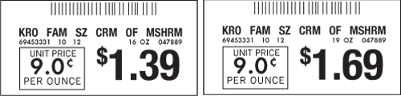
Notice that the unit price for both cans of soup is the same; therefore, the shopper is not saving by buying the larger size. Comparing the unit price of similar products will ensure that you get the best deal available without having to do the math (Virginia Cooperative Extension, 2010).

- Take every opportunity to walk.

  - Walking is a great, low-impact way to get your daily exercise.
  - Don’t always look for the parking space nearest the door. Park farther out an walk!

If you are interested in nutrition classes offered by Better Living for Texans, contact the Family and Consumer Sciences Agent at your local Texas AgriLife Extension: ___________________________________________________________
______________________________________________________

Featured Recipe: Farmer’s Market Salsa (Cost per recipe: $2.71, per serving: $0.34)
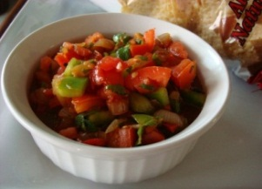
Ingredients
1/2 cup fresh cooked or frozen corn
1 can (15 ounce) drained and rinsed black beans
1 cup fresh diced tomatoes
1/2 cup diced onion
1/2 cup diced green pepper
2 Tablespoons lime juice
2 finely chopped garlic cloves
1/2 cup picante sauce
The tomatoes in fresh salsa are a good source of the anti-oxidant lycopene. Adding fruit to a salsa can provide additional nutrients, sweetness, and flavor to your dish

Serving Size
Yields 8 servings

Instructions
1. Combine all ingredients in a large bowl. Chill until serving time.
2. Drain before serving and serve with low fat baked tortilla chips or fresh vegetables.
