Tis’ the Season to Be Grilling!
May is the unofficial start of the grilling season and many of us will start on Memorial Day as we gather with family and friends to honor our fallen soldiers. The smell of grilled hot dogs and burgers will fill the air. While grilled meats are a favorite, there are additional ways to use an outdoor grill to prepare nutritious and inexpensive foods for you and your family.
Choosing meats:
The most popular meats to grill are beef, chicken, and pork. Select from the leg or loins, which have less fat, when choosing cuts of meat. Remove any outside fat or fat in between muscles before grilling. With chicken, remember that white meat cuts are leaner but dark meats are known to be juicier after grilling. Try to keep serving sizes to 2 ½ to 3-ounce portions of meat.
Grilling Alternatives:
- Grilled vegetables are a tasty, nutritious treat that can be prepared in minutes on an outdoor grill. Just let your imagination run free and be creative (also, keep in mind your budget when choosing which vegetables to buy). Some suggestions are peppers, onions, squash, eggplant, tomatoes, and corn.
- Grilled fruit is a wonderful and healthy alternative to the typical holiday dessert. Some of the more popular fruits to place on the grill are apples tossed in lemon juice and cinnamon, pineapple, peaches, bananas, and mangoes!
You can make a sanitizing solution by mixing 1 teaspoon of bleach with 1 quart of water. If you are away from home and have no hot water, use cutting boards only once. Do not use again until sanitized.

Safety tips when grilling:

Grilling outdoors with the family can create fun memories—just be sure to do it safely to avoid foodborne illnesses by doing the following:
- Wash hands before and after touching raw meat, poultry, or seafood.
- Wash work surfaces and cutting boards with hot soapy water and sanitize before and after grilling.
- Use one cutting board for fresh produce and another for raw meats.
- After placing raw meat, poultry, fish or seafood on the grill wash utensils and platters with hot soapy water before using them to serve the cooked food in order to prevent contaminating cooked foods.
- Use a food thermometer to ensure food is cooked at safe temperatures.

Figure 1shows the minimum internal temperature a food needs to reach to be eaten safely.
Figure 1
ITEM | SIZE | GRILLING TIME | INTERNAL TEMP (F)
Beef (hamburgers) | ½” thick | 3 minutes per side | 160 degrees
Pork ribs | 2 to 4 lbs | 1 ½ to 2 hours | 160 degrees
Poultry | 4 to 7 lbs | 1 to 1 ¾ hours | 165 degrees

- To check the temperature, place the thermometer in the center-most part of the food-away from any bone. If the food is not done, continue to cook. Be sure to wash the thermometer before reusing.
- Flip meat, poultry, and fish at least one time to ensure even cooking. If you are cooking fish that is thin (less than ½ inch thick), turning is not necessary.

VEGGIE OF THE MONTH
Bell peppers are a great source of vitamins A and C. In addition to the taste, they can provide a colorful addition to a meal. Bell peppers are available year round but are cheaper during the summer months. They come in the colors of yellow, green, and red.
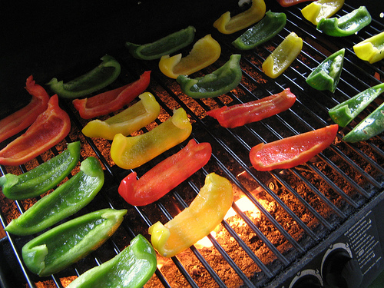
A red bell pepper is a mature green bell pepper. The peppers become sweeter and milder as they age. Red peppers contain eleven times more beta carotene (antioxidants) than green bell peppers. Bell peppers should be stored in a plastic bag in the refrigerator for about a week. Green bell peppers stay fresh a little longer than red and yellow varieties. (Fruitsandveggiesmatter.gov).

Recipe:

Grilled Vegetable Packets (Adapted from Connecticut Food Policy Council)
Serving Size: 3/4 cup, Yield: 5 servings 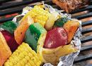

Ingredients:
2 zucchinis, small sliced; 2 yellow squash, small sliced; 4 red potatoes, small scrubbed well and sliced;
1/2 red onion sliced; 1/2 bell pepper (red or green) seeded and sliced; 1/4 cup Italian salad dressing;
Instructions:
1. Heat grill to Medium heat or 350 degrees.
2. Wash vegetables and slice.
3. Toss in a large bowl. Add dressing and toss until all vegetables are coated.
4. Tear 2 large squares of aluminum foil and place half of the vegetable mixture on each piece. Place an equal piece of foil over the top of vegetable mixture and fold bottom piece with top sheet to form a packet.
5. Place on heated grill for 20-30 minutes or until the potatoes are tender. If you don't have a grill bake Veggie Packets in the oven at 400 degrees for 20-30 minutes.
6. Before you open the packets, poke holes in the foil with a fork. Be very careful opening the foil as the steam will be very hot and could burn you!
7. Empty vegetables onto serving plate or serve from foil packets.
Tip! Try different vegetables- Tomatoes, green beans, sweet potatoes, mushrooms, broccoli, carrots, corn or your favorites. Use herbs or spices in place of dressing--Chili powder, Italian or oriental seasoning, basil, oregano, curry powder--be creative and enjoy!
Cost per recipe: $2.78
Cost per serving: $0.56

